GRACE LUTHERAN CHAPEL
Grace Chapel exists to make and keep disciples for Jesus Christ.

Ninth Sunday after Pentecost/Installation of Rev. Eric Stacey
Sunday, August 2, 2020 - 9:30 a.m.

Welcome to Grace Lutheran Chapel and to our worship with Holy Communion. As Lutheran Christians we believe and confess that Christ’s Body and Blood are present in the bread and wine of Holy Communion. This meal benefits those who acknowledge and confess their sin and trust in Christ alone for their salvation. Where Christ’s true body and blood are present, so also is the forgiveness of sins and eternal life. Baptized and instructed Christians who share in this belief are welcome to this meal of our Lord’s grace and forgiveness.

WELCOME/ANNOUNCEMENTS/GREETING

HYMN OF INVOCATION “We Praise You and Acknowledge You, O God,” No. 941
1 We praise You and acknowledge You, O God, to be the Lord,
The Father everlasting, by all the earth adored.
To You all angel powers cry aloud, the heavens sing,
The cherubim and seraphim their praises to You bring:
“O holy, holy, holy Lord God of Sabaoth;
Your majesty and glory fill the heavens and the earth!”

2 The band of the apostles in glory sing Your praise;
The fellowship of prophets their deathless voices raise.
The martyrs of Your kingdom, a great and noble throng,
Sing with the holy Church throughout all the world this song:
“O all-majestic Father, Your true and only Son,
And Holy Spirit, Comforter—forever Three in One!”

3 You, Christ, are King of glory, the everlasting Son,
Yet You, with boundless love, sought to rescue ev’ryone:
You laid aside Your glory, were born of virgin’s womb,
Were crucified for us and were placed into a tomb;
Then by Your resurrection You won for us reprieve—
You opened heaven’s kingdom to all who would believe.

4 You sit in splendid glory, enthroned at God’s right hand,
Upholding earth and heaven by forces You command.
We know that You will come as our Judge that final day,
So help Your servants You have redeemed by blood, we pray;
May we with saints be numbered where praises never end,
In glory everlasting. Amen, O Lord, amen!
Text: © 1999 Stephen P. Starke, admin. Concordia Publishing House. Used by permission: LSB Hymn License no. 110003490

CONFESSION AND ABSOLUTION
In the name of the Father and of the  Son and of the Holy Spirit.
Amen.

If we say we have no sin, we deceive ourselves, and the truth is not in us.
But if we confess our sins, God, who is faithful and just, will forgive our sins and cleanse us from all unrighteousness.

(Silence for reflection on God's Word and for self-examination.)

Let us then confess our sins to God our Father.
Most merciful God, we confess that we are by nature sinful and unclean. We have sinned against You in thought, word, and deed, by what we have done and by what we have left undone. We have not loved You with our whole heart; we have not loved our neighbors as ourselves. We justly deserve Your present and eternal punishment. For the sake of Your Son, Jesus Christ, have mercy on us. Forgive us, renew us, and lead us, so that we may delight in Your will and walk in Your ways to the glory of Your holy name. Amen.

Almighty God in His mercy has given His Son to die for you and for His sake forgives you all your sins. As a called and ordained servant of Christ, and by His authority, I therefore forgive you all your sins in the name of the Father and of the  Son and of the Holy Spirit.
Amen.
HYMN OF PRAISE “O Lord, We Praise You,” No. 617 1 O Lord, we praise Thee, bless Thee, and adore Thee,
In thanksgiving bow before Thee.
Thou with Thy body and Thy blood didst nourish
Our weak souls that they may flourish: O Lord, have mercy!
May Thy body, Lord, born of Mary, That our sins and sorrows did carry,
And Thy blood for us plead
In all trial, fear, and need: O Lord, have mercy!
2 Thy holy body into death was given, Life to win for us in heaven.
No greater love than this to Thee could bind us;
May this feast thereof remind us! O Lord, have mercy!
Lord, Thy kindness did so constrain Thee
That Thy blood should bless and sustain me.
All our debt Thou hast paid;
Peace with God once more is made: O Lord, have mercy!
3 May God bestow on us His grace and favor That we follow Christ our Savior
And live together here in love and union
Nor despise this blest Communion! O Lord, have mercy!
Let not Thy good Spirit forsake us;
Grant that heav’nly-minded He make us;
Give Thy Church, Lord, to see
Days of peace and unity: O Lord, have mercy!
Text: © 1941 Concordia Publishing House. Used by permission: LSB Hymn License no. 110003490

SALUTATION
The Lord be with you.
And also with you.
COLLECT OF THE DAY
Let us pray. Merciful God, we humbly implore You to cast the bright beams of Your light upon Your Church that we, being instructed by the doctrine of the blessed apostles, may walk in the light of Your truth and finally attain to the light of everlasting life; through Jesus Christ, our Lord, who lives and reigns with You and the Holy Spirit, one God, now and forever.
Amen.

OLD TESTAMENT READING Isaiah 52:7-10
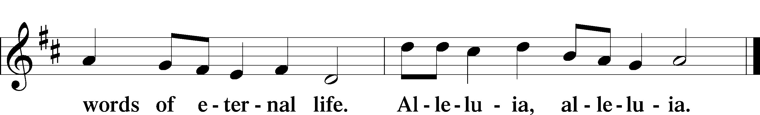
⁷ How beautiful upon the mountains are the feet of him who brings good news, who publishes peace, who brings good news of happiness, who publishes salvation, who says to Zion, “Your God reigns.” ⁸ The voice of your watchmen—they lift up their voice; together they sing for joy;
for eye to eye they see the return of the Lord to Zion. ⁹ Break forth together into singing, you waste places of Jerusalem, for the Lord has comforted his people; he has redeemed Jerusalem. ¹⁰ The Lord has bared his holy arm before the eyes of all the nations, and all the ends of the earth shall see the salvation of our God.
This is the Word of the Lord. Thanks be to God.
PSALM Psalm 40:3-4, 7-11, 16 (spoken responsively)
³ He put a new song in my mouth, a song of praise to our God. Many will see and fear,
and put their trust in the Lord.
⁴ Blessed is the man who makes the Lord his trust, who does not turn to the proud, to those who go astray after a lie!

⁷ Then I said, “Behold, I have come; in the scroll of the book it is written of me:
⁸ I delight to do your will, O my God; your law is within my heart.”

⁹ I have told the glad news of deliverance in the great congregation; behold, I have not restrained my lips, as you know, O Lord.
¹⁰ I have not hidden your deliverance within my heart; I have spoken of your faithfulness and your salvation; I have not concealed your steadfast love and your faithfulness from the great congregation.

¹¹ As for you, O Lord, you will not restrain your mercy from me; your steadfast love and your faithfulness will ever preserve me!
¹⁶ But may all who seek you rejoice and be glad in you; may those who love your salvation say continually, “Great is the Lord!”

EPISTLE Romans 10:14–17
¹⁴ How then will they call on him in whom they have not believed? And how are they to believe in him of whom they have never heard? And how are they to hear without someone preaching? ¹⁵ And how are they to preach unless they are sent? As it is written, “How beautiful are the feet of those who preach the good news!” ¹⁶ But they have not all obeyed the gospel. For Isaiah says, “Lord, who has believed what he has heard from us?” ¹⁷ So faith comes from hearing, and hearing through the word of Christ.
This is the Word of the Lord. Thanks be to God.
HOLY GOSPEL John 20:19–23 The Holy Gospel according to St. John, the twentieth chapter.
Glory to You, O Lord.
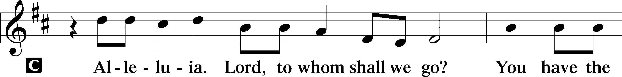

¹⁹ On the evening of that day, the first day of the week, the doors being locked where the disciples were for fear of the Jews, Jesus came and stood among them and said to them, “Peace be with you.” ²⁰ When he had said this, he showed them his hands and his side. Then the disciples were glad when they saw the Lord. ²¹ Jesus said to them again, “Peace be with you. As the Father has sent me, even so I am sending you.” ²² And when he had said this, he breathed on them and said to them, “Receive the Holy Spirit. ²³ If you forgive the sins of any, they are forgiven them; if you withhold forgiveness from any, it is withheld.”

This is the Gospel of the Lord. Praise to You, O Christ.
NICENE CREED
I believe in one God, the Father Almighty, maker of heaven and earth and of all things visible and invisible.
And in one Lord Jesus Christ, the only-begotten Son of God, begotten of his Father before all worlds, God of God, Light of Light, very God of very God, begotten, not made, being of one substance with the Father, by whom all things were made; who for us men and for our salvation came down from heaven and was incarnate by the Holy Spirit of the virgin Mary and was made man; and was crucified also for us under Pontius Pilate. He suffered and was buried. And the third day he rose again according to the Scriptures and ascended into heaven and sits at the right hand of the Father. And he will come again with glory to judge both the living and the dead, whose kingdom will have no end.
And I believe in the Holy Spirit, the Lord and giver of life, who proceeds from the Father and the Son, who with the Father and the Son together is worshiped and glorified, who spoke by the prophets. And I believe in one holy Christian and apostolic Church, I acknowledge one Baptism for the remission of sins, and I look for the resurrection of the dead and the life of the world to come. Amen.

OFFERING PRAYER

SERMON “I Am Sending You”
John 20:19-23 – Pastor Nate Ruback

SERMON HYMN “Here I Am Lord” Praise Team
I, the Lord of sea and sky, I have heard my people cry.
All who dwell in deepest sin, My hand will save.
I, who made the stars of night, I will make their darkness bright
Who will bear my light to them? Whom shall I send?
Chorus: Here I am, Lord. Is it I, Lord? I have heard you calling in the night.
I will go, Lord, if you lead me I will hold your people in my heart.

I, the Lord of snow and rain, I have borne my people's pain.
I have wept for love of them. They turn away.
I will break their hearts of stone, Give them hearts for love alone.
I will speak my word to them? Whom shall I send?
Chorus: Here I am, Lord. Is it I, Lord? I have heard you calling in the night.
I will go, Lord, if you lead me I will hold your people in my heart.
I, the Lord of wind and flame, I will tend the poor and lame.
I will set a feast for them, My hand will save.
Finest bread I will provide 'Til their hearts be satisfied.
I will give my life to them. Whom shall I send?
Chorus: Here I am, Lord. Is it I, Lord? I have heard you calling in the night.
I will go, Lord, if you lead me I will hold your people in my heart.

PRAYER OF THE CHURCH
Let us pray for the whole people of God in Christ Jesus and for all people
according to their needs.
Hungry and thirsty we come to You, O Lord, and we pray You to supply us with all things needful to this body and life, and to teach us to receive Your gifts with thanksgiving. Lord, in Your mercy,
hear our prayer.

With restless hearts we come to You, O Lord, and we pray that by faith we rest our hopes, dreams, anxieties, and needs upon Your everlasting arms and find contentment and peace. Lord, in Your mercy,
hear our prayer.

Knowing that all power is Yours both in heaven and on earth, we thank You for
all the blessings bestowed upon us in this nation and for those who govern for
the protection of the weak, the punishment of the evildoer, and the
encouragement of virtue. Lord, in Your mercy,
hear our prayer.

Broken and wounded, we come to You, O Lord, for healing, comfort, and consolation. Hear us on behalf of all those who cry to You in any need, that Your gracious will be done and all be preserved in affliction and raised to everlasting life. Lord, in Your mercy,
hear our prayer.

Mindful of the poor and those who struggle with daily needs, we ask You, O Lord, to grant us the good fruits of the earth and the fruits of our honest labors to supply what we need and for the poor, the needy, and the unemployed. Lord, in Your mercy,
hear our prayer.

Bidden by Your Word, we come as Your baptized people to feast upon the very flesh of Christ in this bread and His blood in this cup. Grant us the Holy Spirit that we receive these holy gifts in faith and manifest the full fruits of repentance in lives of faith and obedience. Lord, in Your mercy,
hear our prayer.

Into Your hands, O Lord, we commend ourselves and all for whom we pray, trusting in Your mercy, through Your Son, Jesus Christ, our Lord.
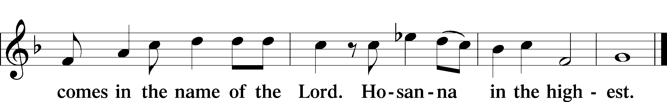
Amen.

SERVICE OF INSTALLATION

SERVICE OF THE SACRAMENT

PREFACE
The Lord be with you.
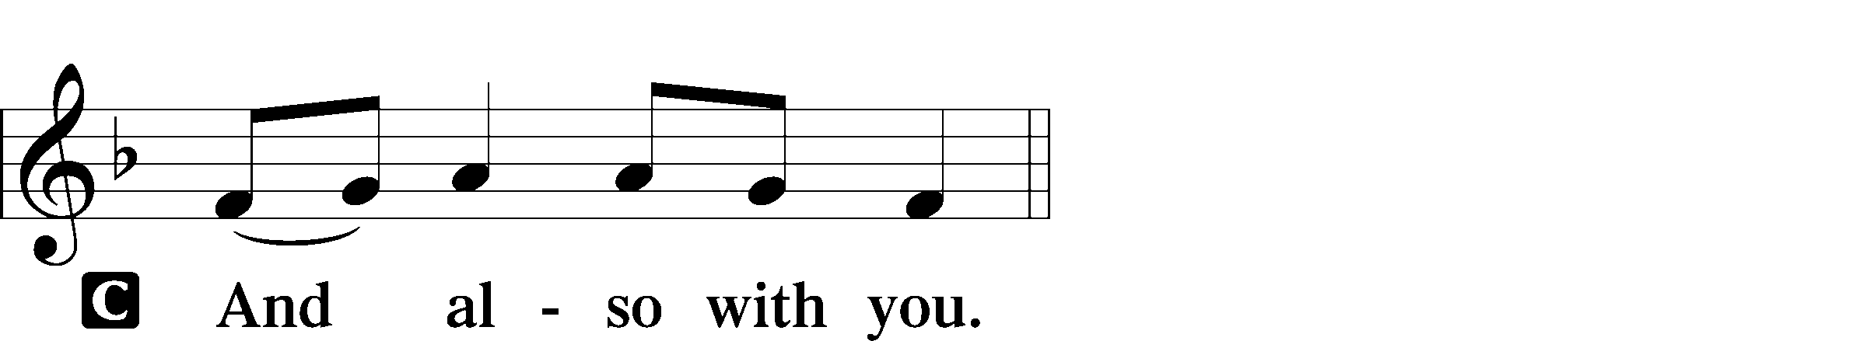

Lift up you hearts.

Let us give thanks to the Lord our God.
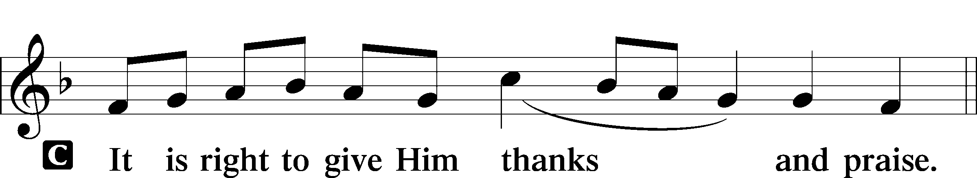

SANCTUS
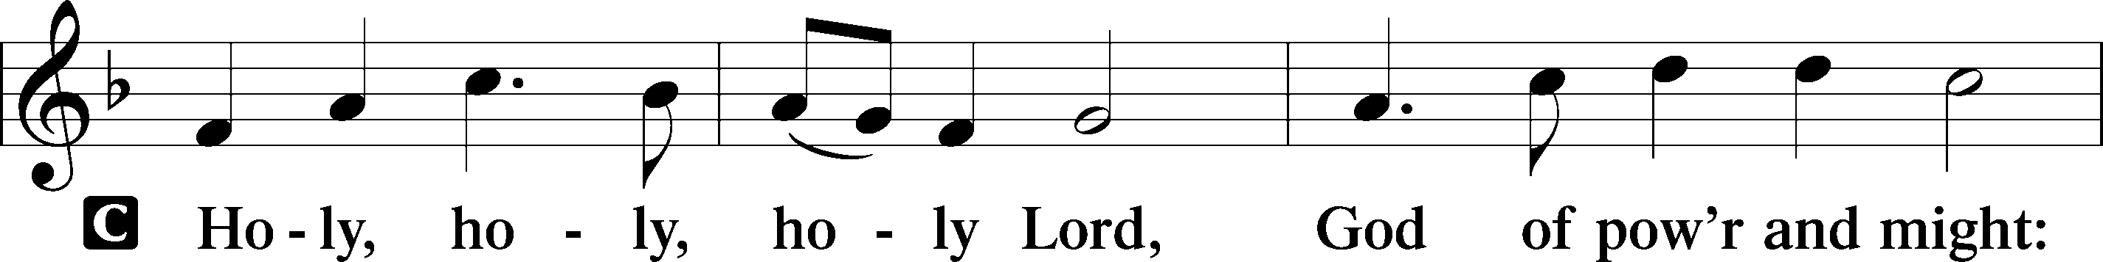

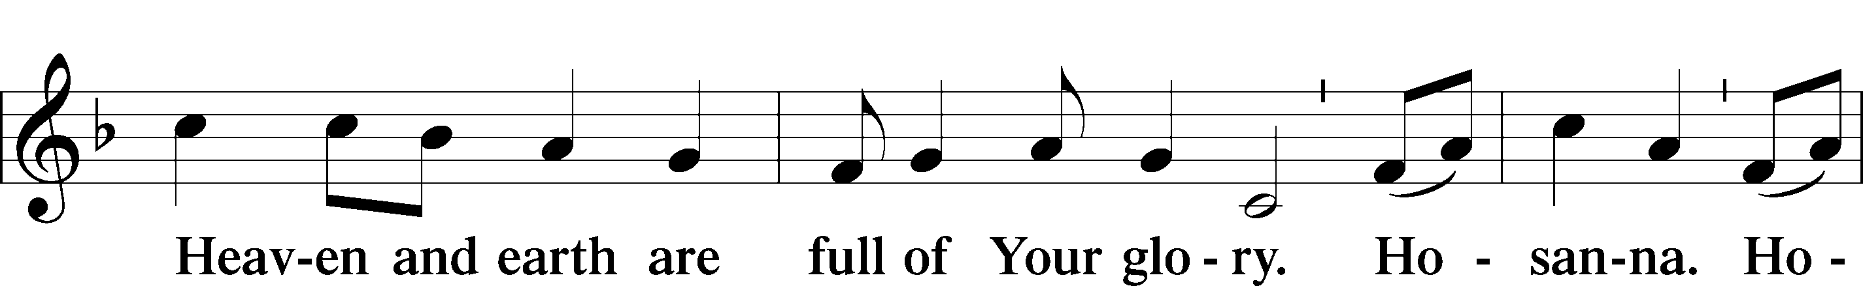

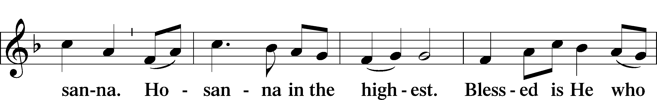

PRAYER OF THANKSGIVING
Blessed are You, Lord of heaven and earth, for You have had mercy on those whom You created and sent Your only-begotten Son into our flesh to bear our sin and be our Savior. With repentant joy we receive the salvation accomplished for us by the all-availing sacrifice of His body and His blood on the cross.

Gathered in the name and the remembrance of Jesus, we beg You, O Lord, to forgive, renew, and strengthen us with Your Word and Spirit. Grant us faithfully to eat His body and drink His blood as He bids us do in His own testament. Gather us together, we pray, from the ends of the earth to celebrate with all the faithful the marriage feast of the Lamb in His kingdom, which has no end. Graciously receive our prayers; deliver and preserve us. To You alone, O Father, be all glory, honor, and worship, with the Son and the Holy Spirit, one God, now and forever.
Amen.

WORDS OF OUR LORD
Our Lord Jesus Christ, on the night when He was betrayed, took bread, and when He had given thanks, He broke it and gave it to the disciples and said: “Take, eat; this is My + body, which is given for you. This do in remembrance of Me.”
In the same way also He took the cup after supper, and when He had given thanks, He gave it to them, saying: “Drink of it, all of you; this cup is the new testament in My + blood, which is shed for you for the forgiveness of sins. This do, as often as you drink it, in remembrance of Me.”

LORD’S PRAYER
Our Father, who art in heaven, hallowed be thy name, thy kingdom come, thy will be done on earth as it is in heaven. Give us this day our daily bread; and forgive us our trespasses, as we forgive those who trespass against us; and lead us not into temptation, but deliver us from evil. For thine is the kingdom and the power and the glory forever and ever. Amen.

DISMISSAL BLESSING
The body and blood of our Lord Jesus Christ strengthen and preserve you in body and soul to life everlasting. Depart + in peace.
Amen.

BENEDICTION
The Lord bless you and keep you.
The Lord make His face shine on you and be gracious to you.
The Lord look upon you with favor and + give you peace.

DISTRIBUTION DURING SINGING OF THE CLOSING HYMN

CLOSING SONGS “Hallelujah for the Cross” “New Doxology” Praise Team
Up to the hill of Calvary​ My Savior went ​courageously​
And there he bled ​and died for me​ Hallelujah for the cross.
And on that day ​the world was changed​ A final, perfect lamb ​was slain​
Let earth and heaven ​now proclaim​ Hallelujah for the cross.

Chorus: Hallelujah for the war ​He fought​ Love has won, ​death has lost​
Hallelujah for the souls ​He bought​ Hallelujah for the cross.
What good I’ve done ​could never save​ My debt too great ​for deeds to pay​
But God, my Savior,​ made a way​ Hallelujah for the cross.
A slave to sin, ​my life was bound​ But all my chains ​fell to the ground​
When Jesus’ blood ​came flowing down​ Hallelujah for the cross.

Chorus: Hallelujah for the war He fought Love has won, death has lost
Hallelujah for the souls He bought Hallelujah for the cross.

Hallelujah, hallelujah​
And when I breathe ​my final breath​ I’ll have no need ​to fear that rest
This hope will guide me​ into death​ Hallelujah for the cross.

Chorus: Hallelujah for the war He fought Love has won, death has lost
Hallelujah for the souls He bought Hallelujah for the cross.

Hallelujah for the cross!​ Hallelujah for the cross!
Hallelujah for the Cross” words and music by Ross King & Todd Wright.
2012 Christian Taylor Music. CCLI #1092956

POSTLUDE

Grace is for all.

Participants
Preacher . . . . . . . . . . . . . . . . . . . . . . . . . . . . . . . . . . . . . . . . . . . . . . Pastor Nate Ruback
Officiant . . . . . . . . . . . . . . . . . . . . . . . . . . . . . . . . . . . . . . . . . . . . . Rev. William Marler
Music. . . . . . . . . . . . . . . . . . . . . . . . . . . . . . . . . . . . . . . . .Praise Team, Brass Ensemble
Mrs. Lisa Fackler, Organist

