GRACE LUTHERAN CHAPEL
Grace Chapel exists to make and keep disciples for Jesus Christ.

First Sunday in Advent
Saturday, November 28, 2020, 4:00 p.m.
Sunday, November 29, 2020, 8:00 a.m.

WELCOME/GREETING

OPENING HYMN “O Come, O Come, Emmanuel,” No. 357, vv. 1, 2, 6 and 7
1 O come, O come, Emmanuel, And ransom captive Israel,
That mourns in lonely exile here Until the Son of God appear. Refrain

Refrain: Rejoice! Rejoice! Emmanuel
Shall come to thee, O Israel!

2 O come, Thou Wisdom from on high, Who ord’rest all things mightily;
To us the path of knowledge show, And teach us in her ways to go. Refrain

6 O come, Thou Dayspring from on high, And cheer us by Thy drawing nigh;
Disperse the gloomy clouds of night, And death’s dark shadows put to flight. Refrain

7 O come, Desire of nations, bind In one the hearts of all mankind;
Bid Thou our sad divisions cease, And be Thyself our King of Peace. Refrain

INVOCATION
In the name of the Father and of the Son and of the Holy Spirit.
Amen.
OPENING SENTENCES

Beloved in the Lord, Advent has come upon us and reminds us that the King is coming. Before we can meet Him, we need to be cleansed from our sin and restored by His grace. So now we come at His invitation to receive His promised grace.

Behold, your King is coming to you; righteous and having salvation. Zachariah 9:9
To You, O Lord, I lift up my soul.

O my God, in You I trust; let me not be put to shame;
let not my enemies exult over me. Indeed, none who wait for You shall be put to shame. Psalm 25:1-3
CONFESSION and ABSOLUTION
(Silence for reflection)
Let us confess our sin in the presence of God and of one another.
I confess to God Almighty, before the whole company of heaven and to you, my brothers and sisters, that I have sinned in thought, word, and deed by my fault, by my own fault, by my own most grievous fault; wherefore I pray God Almighty to have mercy on me, forgive me all my sins, and bring me to everlasting life. Amen.

Almighty God in His mercy has given His Son to die for you and for His sake forgives you all your sins. As a called and ordained servant of Christ, and by His authority, I therefore forgive you all your sins in the name of the Father and of the + Son and of the Holy Spirit.
Amen.

LIGHTING THE ADVENT CANDLE
Jesus Christ is the Light of the world,
the light no darkness can overcome.
Let Your light scatter the darkness
and illumine Your Church.

ADVENT HYMN "Come, Thou Precious Ransom, Come," No. 350, sta. 1
Come, Thou precious Ransom, come, Only hope for sinful mortals!
Come, O Savior of the world! Open are to Thee all portals.
Come, Thy beauty let us see; Anxiously we wait for Thee.

SALUTATION
The Lord be with you.
And also with you.

PRAYER OF THE DAY
Let us pray. By Your own great power, O Lord, we pray that You come to us to protect us by Your might from all evil, and deliver and save us from our sins; for You live and reign with the Father and the Holy Spirit, one God, now and forever.
Amen.

OLD TESTAMENT READING Isaiah 64:1-9
Oh that you would rend the heavens and come down, that the mountains might quake at your presence—² as when fire kindles brushwood and the fire causes water to boil—to make your name known to your adversaries, and that the nations might tremble at your presence! ³ When you did awesome things that we did not look for, you came down, the mountains quaked at your presence. ⁴ From of old no one has heard or perceived by the ear, no eye has seen a God besides you, who acts for those who wait for him. ⁵ You meet him who joyfully works righteousness, those who remember you in your ways. Behold, you were angry, and we sinned; in our sins we have been a long time, and shall we be saved? ⁶ We have all become like one who is unclean, and all our righteous deeds are like a polluted garment. We all fade like a leaf, and our iniquities, like the wind, take us away. ⁷ There is no one who calls upon your name, who rouses himself to take hold of you; for you have hidden your face from us, and have made us melt in the hand of our iniquities. ⁸ But now, O Lord, you are our Father; we are the clay, and you are our potter; we are all the work of your hand. ⁹ Be not so terribly angry, O Lord, and remember not iniquity forever. Behold, please look, we are all your people.

This is the Word of the Lord. Thanks be to God.

EPISTLE 1 Corinthians 1:3-9
3 Grace to you and peace from God our Father and the Lord Jesus Christ. 4 I give thanks to my God always for you because of the grace of God that was given you in Christ Jesus, 5 that in every way you were enriched in him in all speech and all knowledge— 6 even as the testimony about Christ was confirmed among you— 7 so that you are not lacking in any gift, as you wait for the revealing of our Lord Jesus Christ, 8 who will sustain you to the end, guiltless in the day of our Lord Jesus Christ. 9 God is faithful, by whom you were called into the fellowship of his Son, Jesus Christ our Lord.

This is the Word of the Lord. Thanks be to God.

VERSE Psalm 24:7
Alleluia, alleluia, alleluia.
Lift up your heads, O gates! And be lifted up, O ancient doors, that the King of glory
may come in.
Alleluia, alleluia, alleluia.

GOSPEL Mark 11:1-10
Now when they drew near to Jerusalem, to Bethphage and Bethany, at the Mount of Olives, Jesus sent two of his disciples ² and said to them, “Go into the village in front of you, and immediately as you enter it you will find a colt tied, on which no one has ever sat. Untie it and bring it. ³ If anyone says to you, ‘Why are you doing this?’ say, ‘The Lord has need of it and will send it back here immediately.’” ⁴ And they went away and found a colt tied at a door outside in the street, and they untied it. ⁵ And some of those standing there said to them, “What are you doing, untying the colt?” ⁶ And they told them what Jesus had said, and they let them go. ⁷ And they brought the colt to Jesus and threw their cloaks on it, and he sat on it. ⁸ And many spread their cloaks on the road, and others spread leafy branches that they had cut from the fields. ⁹ And those who went before and those who followed were shouting, “Hosanna! Blessed is he who comes in the name of the Lord! ¹⁰ Blessed is the coming kingdom of our father David! Hosanna in the highest!”

This is the Gospel of the Lord. Praise to You, O Christ.
NICENE CREED
I believe in one God, the Father Almighty, maker of heaven and earth and of all things visible and invisible.
And in one Lord Jesus Christ, the only-begotten Son of God, begotten of his Father before all worlds, God of God, Light of Light, very God of very God, begotten, not made, being of one substance with the Father, by whom all things were made; who for us men and for our salvation came down from heaven and was incarnate by the Holy Spirit of the virgin Mary and was made man; and was crucified also for us under Pontius Pilate. He suffered and was buried. And the third day he rose again according to the Scriptures and ascended into heaven and sits at the right hand of the Father. And he will come again with glory to judge both the living and the dead, whose kingdom will have no end.
And I believe in the Holy Spirit, the Lord and giver of life, who proceeds from the Father and the Son, who with the Father and the Son together is worshiped and glorified, who spoke by the prophets. And I believe in one holy Christian and apostolic Church, I acknowledge one Baptism for the remission of sins, and I look for the resurrection of the dead and the life of the world to come. Amen.

OFFERING PRAYER

SERMON “Are You Ready?”
Mark 11:1-10 – Pastor Nate Ruback

SERMON HYMN “Lo! He Comes with Clouds Descending,” No. 336
1 Lo! He comes with clouds descending,
Once for ev’ry sinner slain;
Thousand thousand saints attending
Swell the triumph of His train:
Alleluia, alleluia, alleluia!
Christ the Lord returns to reign.

2 Ev’ry eye shall now behold Him
Robed in glorious majesty;
Those who set at naught and sold Him,
Pierced and nailed Him to the tree,
Deeply wailing, deeply wailing, deeply wailing,
Shall their true Messiah see.

3 Those dear tokens of His passion
Still His dazzling body bears,
Cause of endless exultation
To His ransomed worshipers.
With what rapture, with what rapture, with what rapture
Gaze we on those glorious scars!

4 Yea, amen, let all adore Thee,
High on Thine eternal throne;
Savior, take the pow’r and glory,
Claim the kingdom as Thine own.
Alleluia, alleluia, alleluia!
Thou shalt reign, and Thou alone!

PRAYER OF THE CHURCH
Let us pray for the whole people of God in Christ Jesus and for all people according to their needs; that we may not be distracted or grow complacent but be ready and waiting for the Lord when He returns in His glory, let us pray:
come, Lord Jesus, restore Your people and lead us home to You.

That the Lord would guide and watch over His Church and all who serve her---pastors, missionaries, and all church workers, let us pray:
come, Lord Jesus, restore Your people and lead us home to You.

That the Lord would bless our every effort to share the good news of Jesus that all the elect may hear and heed His voice calling and gathering His people, let us pray:
come, Lord Jesus, restore Your people and lead us home to You.

That the Lord would bless our nation and leaders, and that they may guide us with wisdom in paths of peace and justice, let us pray:
come, Lord Jesus, restore Your people and lead us home to You.

That the sick and suffering may find healing and relief and that the dying and the grieving may know His comfort and peace, let us pray:
come, Lord Jesus, restore Your people and lead us home to You.

That we may be wise and faithful in our use of all the resources God has entrusted to us and that we may use them for His glory and in support of the work of His kingdom, let us pray:
come, Lord Jesus, restore Your people and lead us home to You.

That God may give us all things we need and all that will benefit us and that He may keep from us all things that might prove harmful to us, let us pray:
come, Lord Jesus, restore Your people and lead us home to You. Amen.

PREFACE
The Lord be with you.
And also with you.

Lift up your hearts.
We lift them to the Lord.

Let us give thanks to the Lord our God.
It is right to give Him thanks and praise.

PROPER PREFACE
It is truly good, right, and salutary that we should at all times and in all places give thanks to You, holy Lord, almighty Father, everlasting God, through Jesus Christ, our Lord, who came as the Son of Mary, the Son of God to live and give His life as a ransom to deliver us and the whole world from the judgment of death for our sins. Therefore with angels and archangels and with all the company of heaven we laud and magnify Your glorious name, evermore praising You and saying:

SANCTUS (p. 208 in hymnal)
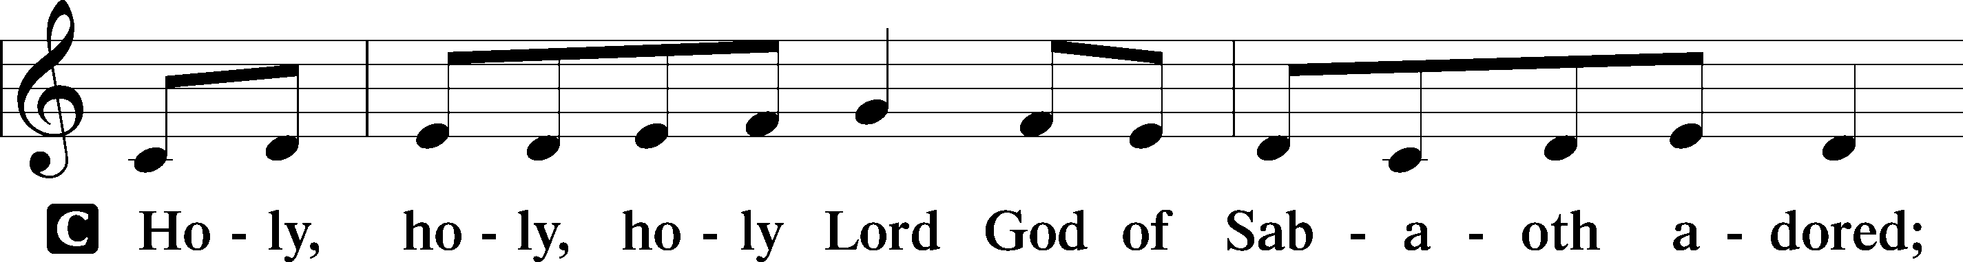

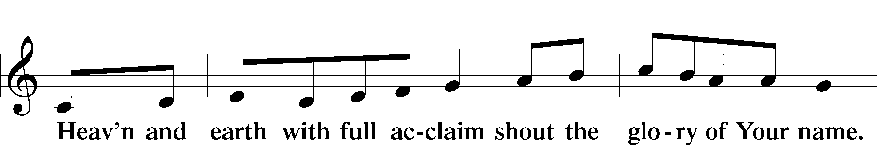

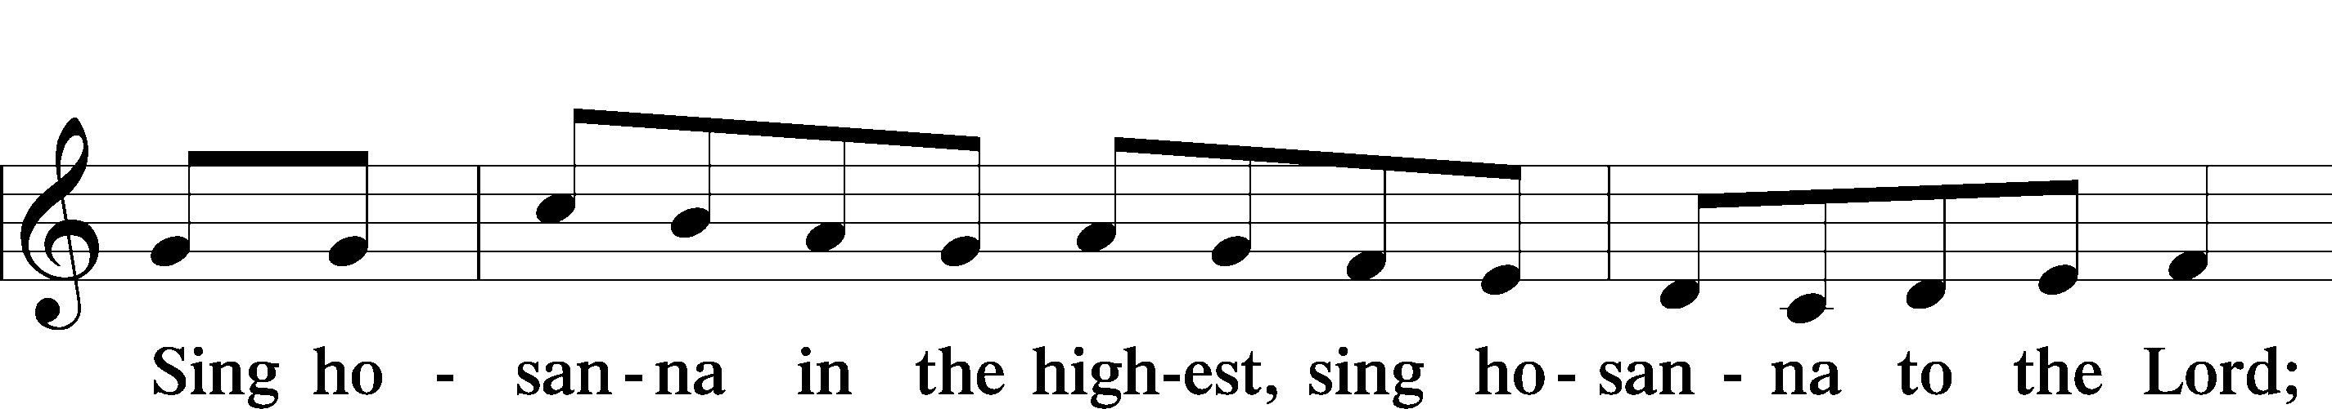

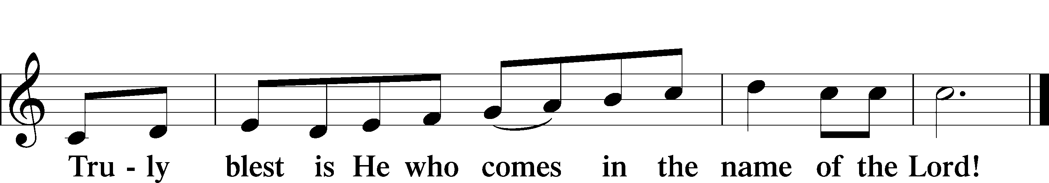

PRAYER OF THANKSGIVING
Blessed are You, O Lord our God, King of all creation, for You have had mercy on us and given Your only-begotten Son, that whoever believes in Him should not perish but have eternal life.
By Your own will of mercy for us, Jesus came as King and was enthroned on a cross that we may be raised to reign with Him, now seated at Your right hand of power. So we pray again in this new year, “Come, Lord Jesus, that by Your protection we may be rescued from the threatening perils of our sins and saved by Your mighty deliverance.”
By Your body and blood, given us to eat and drink, we proclaim Your death until You come again in glory.
Amen.

THE WORDS OF OUR LORD
Our Lord Jesus Christ, on the night when He was betrayed, took bread, and when He had given thanks, He broke it and gave it to the disciples and said: “Take, eat; this is My body, which is given for you. This do in remembrance of Me.”
In the same way also He took the cup after supper, and when He had given thanks, He gave it to them, saying: “Drink of it, all of you; this cup is the new testament in My blood, which is shed for you for the forgiveness of sins. This do, as often as you drink it, in remembrance of Me.”

PROCLAMATION OF CHRIST
As often as we eat this bread and drink this cup, we proclaim the Lord’s death until He comes.
Amen. Come, Lord Jesus.

O Lord Jesus Christ, only Son of the Father, in giving us Your body and blood in this Sacrament You lead us to remember all that You have done for us before we were born, to realize that You are with us today, and to await Your promised return one day to receive us into Your eternal kingdom. So remember us in Your kingdom now and teach us to pray:

LORD’S PRAYER
Our Father Who art in heaven, hallowed be Thy name. Thy kingdom come, Thy will be done on earth as it is in heaven. Give us this day our daily bread; and forgive us our trespasses as we forgive those who trespass against us; and lead us not into temptation, but deliver us from evil. For Thine is the kingdom, and the power, and the glory, forever and ever. Amen.

PAX DOMINI
The peace of the Lord be with you always.
Amen.

DISTRIBUTION HYMNS:
“Lord Jesus Christ, We Humbly Pray,” No. 623
1 Lord Jesus Christ, we humbly pray That we may feast on You today;
Beneath these forms of bread and wine Enrich us with Your grace divine.

2 Give us, who share this wondrous food, Your body broken and Your blood,
The grateful peace of sins forgiv’n, The certain joys of heirs of heav’n.

3 By faith Your Word has made us bold To seize the gift of love retold;
All that You are we here receive, And all we are to You we give.

4 One bread, one cup, one body, we, Rejoicing in our unity,
Proclaim Your love until You come To bring Your scattered loved ones home.

5 Lord Jesus Christ, we humbly pray: O keep us steadfast till that day
When each will be Your welcomed guest In heaven’s high and holy feast.

“Savior of the Nations, Come,” No. 332
1 Savior of the nations, come, Virgin’s Son, make here Your home!
Marvel now, O heav’n and earth, That the Lord chose such a birth.

2 Not by human flesh and blood, By the Spirit of our God,
Was the Word of God made flesh—Woman’s offspring, pure and fresh.

3 Here a maid was found with child, Yet remained a virgin mild.
In her womb this truth was shown: God was there upon His throne.

4 Then stepped forth the Lord of all From His pure and kingly hall;
God of God, yet fully man, His heroic course began.

5 God the Father was His source, Back to God He ran His course.
Into hell His road went down, Back then to His throne and crown.

6 For You are the Father’s Son Who in flesh the vict’ry won.
By Your mighty pow’r make whole All our ills of flesh and soul.

7 From the manger newborn light Shines in glory through the night.
Darkness there no more resides; In this light faith now abides.

8 Glory to the Father sing, Glory to the Son, our king,
Glory to the Spirit be Now and through eternity.
Text (sts. 3, 6–7): © 2006 Concordia Publishing House; (sts. 4–5, 8): © 1978 Concordia Publishing
House. Used by permission: LSB Hymn License no. 110003490 Text (sts. 1–2): Public domain

POST-COMMUNION THANKSGIVING
Let us pray. Gracious God, our heavenly Father, You have given us a foretaste of the feast to come in the Holy Supper of Your Son’s body and blood. Keep us firm in the true faith throughout our days of pilgrimage that, on the day of His coming, we may, together with all Your saints, celebrate the marriage feast of the Lamb in His kingdom, which has no end; through Jesus Christ, Your Son, our Lord, who lives and reigns with You and the Holy Spirit, one God, now and forever.
Amen.

BENEDICTION
The Lord bless you and keep you.
The Lord make His face shine on you and be gracious to you.
The Lord look upon you with favor and give you peace.
Amen.

CLOSING HYMN “The Advent of Our King,” No. 331
1 The advent of our King Our prayers must now employ,
And we must hymns of welcome sing In strains of holy joy.

2 The everlasting Son Incarnate deigns to be,
Himself a servant’s form puts on To set His servants free.

3 O Zion’s daughter, rise To meet your lowly King,
Nor let your faithless heart despise The peace He comes to bring.

4 As judge, on clouds of light, He soon will come again
And His true members all unite With Him in heav’n to reign.

5 Before the dawning day Let sin’s dark deeds be gone,
The sinful self be put away, The new self now put on.

6 All glory to the Son, Who comes to set us free,
With Father, Spirit, ever one Through all eternity.

POSTLUDE

Grace is for all!

