GRACE LUTHERAN CHAPEL
Grace Chapel exists to make and keep disciples for Jesus Christ.

Palm Sunday
Saturday, March 27, 2021 - 4:00 p.m.
Sunday, March 28, 2021 - 8:00 a.m.

(Please Stand)
HOLY GOSPEL - John 12:12–19

The Holy Gospel according to St. John, the Twelfth chapter.
Glory to You, O Lord.

¹² The next day the large crowd that had come to the feast heard that Jesus was coming to Jerusalem. ¹³ So they took branches of palm trees and went out to meet him, crying out, “Hosanna! Blessed is he who comes in the name of the Lord, even the King of Israel!” ¹⁴ And Jesus found a young donkey and sat on it, just as it is written, ¹⁵ “Fear not, daughter of Zion; behold, your king is coming, sitting on a donkey's colt!”
¹⁶ His disciples did not understand these things at first, but when Jesus was glorified, then they remembered that these things had been written about him and had been done to him. ¹⁷ The crowd that had been with him when he called Lazarus out of the tomb and raised him from the dead continued to bear witness. ¹⁸ The reason why the crowd went to meet him was that they heard he had done this sign. ¹⁹ So the Pharisees said to one another, “You see that you are gaining nothing. Look, the world has gone after him.”

This is the Gospel of the Lord.
Praise to You, O Christ.

PROCESSION OF PALMS by Sunday School Children and PROCESSIONAL HYMN
"Hosanna, Loud Hosanna," No. 443 with Handbells
1 Hosanna, loud hosanna, The little children sang;
Through pillared court and temple The lovely anthem rang.
To Jesus, who had blessed them, Close folded to His breast,
The children sang their praises, The simplest and the best.

2 From Olivet they followed Mid an exultant crowd,
The victor palm branch waving And chanting clear and loud.
The Lord of earth and heaven Rode on in lowly state
Nor scorned that little children Should on His bidding wait.

3 “Hosanna in the highest!” That ancient song we sing;
For Christ is our Redeemer, The Lord of heav’n our King.
Oh, may we ever praise Him With heart and life and voice
And in His blissful presence Eternally rejoice!

INVOCATION
In the name of the Father and of the Son and of the Holy Spirit.
Amen.

OPENING SENTENCES
Blessed is He who comes,
who comes in the name of the Lord.

Hosanna to the Son of David.
Hosanna in the highest!

CONFESSION and ABSOLUTION
As we enter this Holy Week of our Lord's Passion, let us confess our sins to God and to one another. God of compassion,
we confess to You that we have sinned against You and against our neighbors. We have been prideful; we have sought to overrule Your authority as Lord of our lives; we have not listened deeply to Your Word. We do not deserve Your kindness to us. In Your abundant compassion, forgive us, Lord, for the sake of Your Son, who gave His life on the cross for us.

The Lord is full of compassion. He gives life. He heals the wounds caused by our sin. Therefore, I, by virtue of my office as a called and ordained servant of the Word, announce the grace of God unto all of you, and in the stead and by the command of my Lord Jesus Christ I forgive you all your sins in the name of the Father and of the + Son and of the Holy Spirit.
Amen.

PRAYER OF THE DAY
Let us pray. Almighty and everlasting God, You sent Your Son, our Savior Jesus Christ, to take upon Himself our flesh and to suffer death upon the cross. Mercifully grant that we may follow the example of His great humility and patience and be made partakers of His resurrection; through the same Jesus Christ, our Lord, who lives and reigns with You and the Holy Spirit, one God, now and forever.
Amen.

OLD TESTAMENT READING Zechariah 9:9-12
⁹ Rejoice greatly, O daughter of Zion! Shout aloud, O daughter of Jerusalem! Behold, your king is coming to you; righteous and having salvation is he, humble and mounted on a donkey, on a colt, the foal of a donkey. ¹⁰ I will cut off the chariot from Ephraim and the war horse from Jerusalem; and the battle bow shall be cut off, and he shall speak peace to the nations; his rule shall be from sea to sea, and from the River to the ends of the earth. ¹¹ As for you also, because of the blood of my covenant with you, I will set your prisoners free from the waterless pit. ¹² Return to your stronghold, O prisoners of hope; today I declare that I will restore to you double.

This is the Word of the Lord. Thanks be to God.

ANTHEM (8:00 a.m.) “Hosanna!” – Chapel Choir

EPISTLE Philippians 2:5-11
⁵ Have this mind among yourselves, which is yours in Christ Jesus, ⁶ who, though he was in the form of God, did not count equality with God a thing to be grasped, ⁷ but emptied himself, by taking the form of a servant, being born in the likeness of men. ⁸ And being found in human form, he humbled himself by becoming obedient to the point of death, even death on a cross. ⁹ Therefore God has highly exalted him and bestowed on him the name that is above every name, ¹⁰ so that at the name of Jesus every knee should bow, in heaven and on earth and under the earth, ¹¹ and every tongue confess that Jesus Christ is Lord, to the glory of God the Father.

This is the Word of the Lord. Thanks be to God.

NICENE’ CREED
I believe in one God, the Father Almighty, maker of heaven and earth and of all things visible and invisible.
And in one Lord Jesus Christ, the only-begotten Son of God, begotten of his Father before all worlds, God of God, Light of Light, very God of very God, begotten, not made, being of one substance with the Father, by whom all things were made; who for us men and for our salvation came down from heaven and was incarnate by the Holy Spirit of the virgin Mary and was made man; and was crucified also for us under Pontius Pilate. He suffered and was buried. And the third day he rose again according to the Scriptures and ascended into heaven and sits at the right hand of the Father. And he will come again with glory to judge both the living and the dead, whose kingdom will have no end.
And I believe in the Holy Spirit, the Lord and giver of life, who proceeds from the Father and the Son, who with the Father and the Son together is worshiped and glorified, who spoke by the prophets. And I believe in one holy Christian and apostolic Church, I acknowledge one Baptism for the remission of sins, and I look for the resurrection of the dead and the life of the world to come. Amen.

OFFERING PRAYER

SERMON “Hosanna!”
John 12:12-19 – Pastor Nate Ruback
SERMON HYMN “All Glory, Laud, and Honor,” No.442 with Handbells
Refrain: All glory, laud, and honor
To You, Redeemer, King,
To whom the lips of children
Made sweet hosannas ring.

1 You are the King of Israel
And David’s royal Son,
Now in the Lord’s name coming,
Our King and Blessèd One. Refrain

2 The company of angels
Is praising You on high,
And we with all creation
In chorus make reply. Refrain

3 The multitude of pilgrims
With palms before You went;
Our praise and prayer and anthems
Before You we present. Refrain

4 To You before Your passion
They sang their hymns of praise;
To You, now high exalted,
Our melody we raise. Refrain

5 As You received their praises,
Accept the prayers we bring,
O Source of ev’ry blessing,
Our good and gracious King. Refrain

PRAYER OF THE CHURCH
In this, the acceptable time---the Lenten season, the Lord invites us to be renewed in mind, purified in spirit, and more responsive to the needs of others. Let us ask God to accompany us on our journey to Easter.

For the Church throughout the world and in this place, that all the baptized people of God may lift up the name of Jesus before all the nations, that every knee may bow in faith and worship Him; for missionaries at home and abroad, that all people may hear the Gospel of Jesus, for pastors, teachers, and all church workers, that they may point all to Jesus and serve as godly examples; for our catechumens, that they may grow in their faith and knowledge of God's Son and follow Him all the days of their lives; let us pray to the Lord:
Lord, have mercy.

For the leaders of the world, that they may be good examples for their people by settling their disagreements without bloodshed and allowing God's people to do His will without fear; for members of our armed forces and innocent civilians in harm's way, that they may know the peace of Christ; for our enemies and for all who wish us harm, that we and they one day forgive one another and live in harmony; let us pray to the Lord:
Lord, have mercy.

For the sick, hospitalized, and those awaiting surgery, that the Lord would heal and strengthen them; for all who mourn, that God would comfort them with His faithful love and victory over death; let us pray to the Lord:
Lord, have mercy.

For us and all Christians, that the Spirit would lead us to give generously and joyfully, acknowledging God as the giver of every gift; for this holy assembly, that our lives may be shaped by the sacrificial suffering and death of Jesus; let us pray to the Lord:
Lord, have mercy.

Hear our prayer, Lord God, and look mercifully upon our repentance; grant that Your Church, cleansed of sin, may approach Easter with spiritual joy; through Jesus Christ, Your Son, our Lord.
Amen.

PREFACE
The Lord be with you.
And also with you.

Lift up your hearts.
We lift them to the Lord.

Let us give thanks to the Lord our God.
It is right to give Him thanks and praise.

PRAYER OF THANKSGIVING
Blessed are You, Lord of heaven and earth, for You have had mercy on those whom You created and sent Your only-begotten Son into our flesh to bear our sin and be our Savior. With repentant joy we receive the salvation accomplished for us by the all-availing sacrifice of His body and His blood on the cross.
Gathered in the name and the remembrance of Jesus, we beg You, O Lord, to forgive, renew, and strengthen us with Your Word and Spirit. Grant us faithfully to eat His body and drink His blood as He bids us do in His own testament. Gather us together, we pray, from the ends of the earth to celebrate with all the faithful the marriage feast of the Lamb in His kingdom, which has no end. Graciously receive our prayers; deliver and preserve us. To You alone, O Father, be all glory, honor, and worship, with the Son and the Holy Spirit, one God, now and forever.
Amen.

THE WORDS OF OUR LORD
Our Lord Jesus Christ, on the night when He was betrayed, took bread, and when He had given thanks, He broke it and gave it to the disciples and said: “Take, eat; this is My body, which is given for you. This do in remembrance of Me.”
In the same way also He took the cup after supper, and when He had given thanks, He gave it to them, saying: “Drink of it, all of you; this cup is the new testament in My blood, which is shed for you for the forgiveness of sins. This do, as often as you drink it, in remembrance of Me.”

PROCLAMATION OF CHRIST
As often as we eat this bread and drink this cup, we proclaim the Lord’s death until He comes.
Amen. Come, Lord Jesus.

O Lord Jesus Christ, only Son of the Father, in giving us Your body and blood to eat and to drink, You lead us to remember and confess Your holy cross and passion, Your blessed death, Your rest in the tomb, Your resurrection from the dead, Your ascension into heaven, and Your coming for the final judgment. So remember us in Your kingdom and teach us to pray:

LORD’S PRAYER
Our Father Who art in heaven, hallowed be Thy name. Thy kingdom come, Thy will be done on earth as it is in heaven. Give us this day our daily bread; and forgive us our trespasses as we forgive those who trespass against us; and lead us not into temptation, but deliver us from evil. For Thine is the kingdom, and the power, and the glory, forever and ever. Amen.

PAX DOMINI
The peace of the Lord be with you always.
Amen.
AGNUS DEI, p. 163
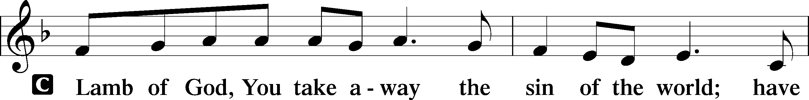
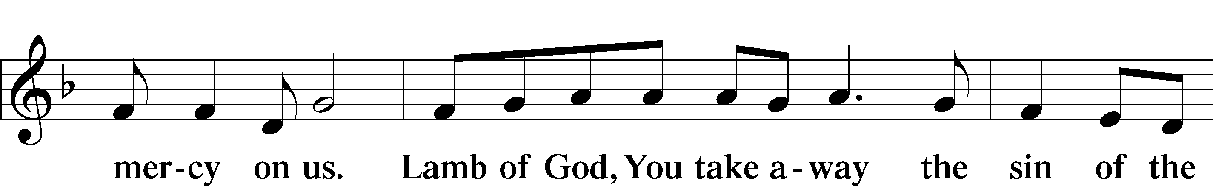
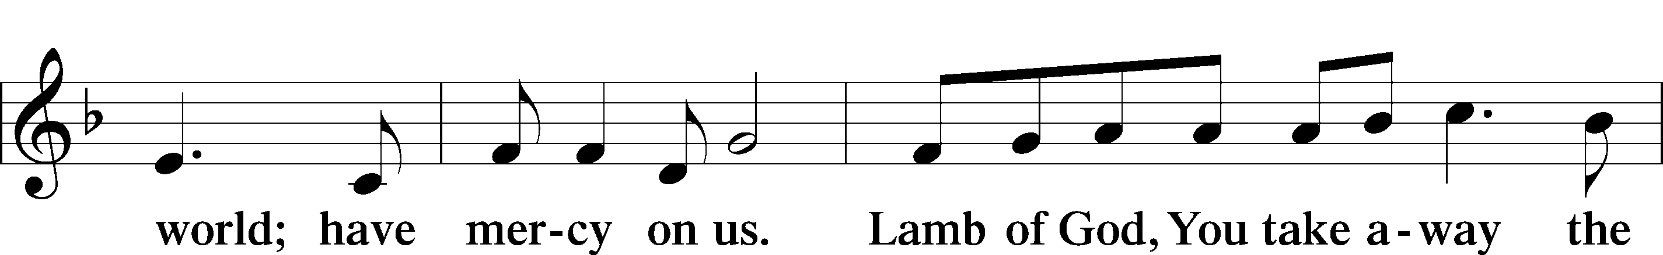
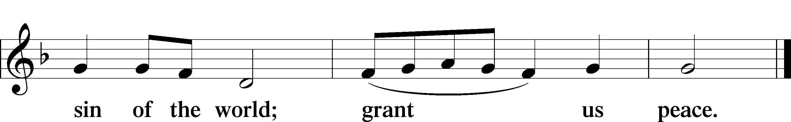

DISTRIBUTION
Distribution Hymns:
“O Perfect Life of Love,” No. 452
1 O perfect life of love! All, all, is finished now,
All that He left His throne above To do for us below.

2 No work is left undone Of all the Father willed;
His toil, His sorrows, one by one, The Scriptures have fulfilled.

3 No pain that we can share But He has felt its smart;
All forms of human grief and care Have pierced that tender heart.

4 And on His thorn-crowned head And on His sinless soul
Our sins in all their guilt were laid That He might make us whole.

5 In perfect love He dies; For me He dies, for me.
O all-atoning Sacrifice, I cling by faith to Thee.

6 In ev’ry time of need, Before the judgment throne,
Thy work, O Lamb of God, I’ll plead, Thy merits, not mine own.

7 Yet work, O Lord, in me As Thou for me hast wrought;
And let my love the answer be To grace Thy love has brought.

“Were You There,” No. 456
1 Were you there when they crucified my Lord?
Were you there when they crucified my Lord?
Oh . . . Sometimes it causes me to tremble,
tremble, tremble.
Were you there when they crucified my Lord?

2 Were you there when they nailed Him to the tree?
Were you there when they nailed Him to the tree?
Oh . . . Sometimes it causes me to tremble,
tremble, tremble.
Were you there when they nailed Him to the tree?

3 Were you there when they laid Him in the tomb?
Were you there when they laid Him in the tomb?
Oh . . . Sometimes it causes me to tremble,
tremble, tremble.
Were you there when they laid Him in the tomb?

4 Were you there when God raised Him from the tomb?
Were you there when God raised Him from the tomb?
Oh . . . Sometimes it causes me to tremble,
tremble, tremble.
Were you there when God raised Him from the tomb?

“A Lamb Goes Uncomplaining Forth,” No. 438
1 A Lamb goes uncomplaining forth,
The guilt of sinners bearing
And, laden with the sins of earth,
None else the burden sharing;
Goes patient on, grows weak and faint,
To slaughter led without complaint,
That spotless life to offer,
He bears the stripes, the wounds, the lies,
The mockery, and yet replies,
“All this I gladly suffer.”

2 This Lamb is Christ, the soul’s great friend,
The Lamb of God, our Savior,
Whom God the Father chose to send
To gain for us His favor.
“Go forth, My Son,” the Father said,
“And free My children from their dread
Of guilt and condemnation.
The wrath and stripes are hard to bear,
But by Your passion they will share
The fruit of Your salvation.”

3 “Yes, Father, yes, most willingly
I’ll bear what You command Me.
My will conforms to Your decree,
I’ll do what You have asked Me.”
O wondrous Love, what have You done!
The Father offers up His Son,
Desiring our salvation.
O Love, how strong You are to save!
You lay the One into the grave
Who built the earth’s foundation.

4 Lord, when Your glory I shall see
And taste Your kingdom’s pleasure,
Your blood my royal robe shall be,
My joy beyond all measure!
When I appear before Your throne,
Your righteousness shall be my crown;
With these I need not hide me.
And there, in garments richly wrought,
As Your own bride shall we be brought
To stand in joy beside You.
Text: © 1941 Concordia Publishing House. Used by permission: LSB Hymn License no. 110003490

DISMISSAL BLESSING

POST-COMMUNION THANKSGIVING
Gracious God, our heavenly Father, You have given us a foretaste of the feast to come in the Holy Supper of Your Son's body and blood. Keep us firm in the true faith throughout our days of pilgrimage that, on the day of His coming, we may, together with all Your saints, celebrate the marriage feast of the Lamb in His kingdom which has no end; through Jesus Christ, Your Son, our Lord, who lives and reigns with You and the Holy Spirit, one God, now and forever.
Amen.

BENEDICTION Psalm 32:10
The Lord is compassionate.
The Lord heals us and restores our lives.

The Lord bless you and keep you.
The Lord make His face shine on you and be gracious to you.
The Lord look upon you with favor and give you peace.
Amen.

CLOSING HYMN “Ride On, Ride On in Majesty,” No. 441
1 Ride on, ride on in majesty! Hark! All the tribes hosanna cry.
O Savior meek, pursue Thy road, With palms and scattered garments strowed.

2 Ride on, ride on in majesty! In lowly pomp ride on to die.
O Christ, Thy triumphs now begin O’er captive death and conquered sin.

3 Ride on, ride on in majesty! The angel armies of the sky
Look down with sad and wond’ring eyes To see the_approaching sacrifice.

4 Ride on, ride on in majesty! Thy last and fiercest strife is nigh.
The Father on His sapphire throne Awaits His own anointed Son.

5 Ride on, ride on in majesty! In lowly pomp ride on to die.
Bow Thy meek head to mortal pain, Then take, O God, Thy pow’r and reign.

POSTLUDE

Grace is for all!

