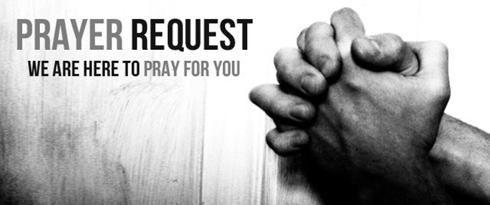

January 9/10, 2021

For those who are sick:

~ Hospitalized: Larry Lee, grandfather of one of our 3rd grade students

~for Chris Tirmenstein who will undergo surgery on Monday, January 11, to remove lymph nodes in her neck

~for the LAMP communities in Lynn Lake and Brochet where Grace Chapel teams have served as they have now reported cases of Covid. We pray that all the First Nation communities can control the spread of the virus as there is little access to local healthcare

~ for Pastor Stacy's "North Carolina" family who have contracted Covid. We please pray for a full recovery for Brandon, Amy, Harley, and Nathan Buff.

~for Pastor Nate's grandmother, Barb Ruback, who has also contracted Covid. We pray that symptoms do not become severe and aggravate her other health issues.

~ for continued healing for Dick Horstmann, Bev Lemen, Dorothy Carroll, Murphy Baker, Judith Hill, Tim Gruenwald, Jerry Eberwein, Bev Bowers, Wilma Jordan, Lana Gieselmann, Doug Neeley , Kerry Horace, Becca Handlang, Terry Crowder, Rick Paul, Summer Crowder, Jim Young, Brenda Nierman and Elizabeth Edwards

~ for Ray Liszewski, Ingrid Nebel, Karen Scheer, Norma Hollmann, and Dennis Jordan as they continue their cancer treatments

~Hospice Care:

Bereaved:

Anniversaries/Birthdays:

~ in celebration of the following birthdays this week: Mark Dickerson (1/10), Linda Eberwein (1/12), Myles Pratt (1/14), Caleb Sm,ith (1/14), Gina Stephens (1/14)Kathy Ehrhard (1/16)

Other:

~for Eric Brofford and God’s direction as he deliberates a Call to be Principal at Trinity Lutheran School in Edwardsville, IL

~for this week’s Grace Chapel School families: Brooklyn Rash (PreK), Charles Jones (3rd), Xacred King (Toddlers), Madison Bradford (4th), Zoe Laesch (5th)

~ For our men and women in uniform - military, fire and police and our EMS and First Responders; along with doctors, nurses and all workers in the medical field