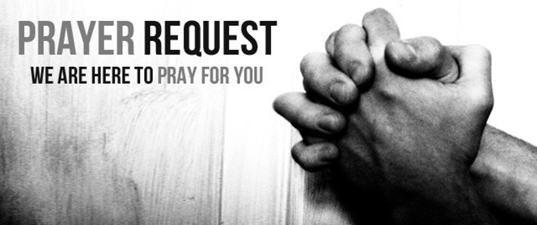

November 21/22, 2020

For those who are sick:

~ Hospitalized: Larry Lee, grandfather of one of our 3rd grade students

~ For continued healing for Dick Horstmann, Bev Lemen, Dorothy Carroll, Murphy Baker, Judith Hill, Tim Gruenwald, Jerry Eberwein, Bev Bowers, Wilma Jordan, Lana Gieselmann, Doug Neeley , Kerry Horace, Becca Handlang, Terry Crowder, Rick Paul, Mark and Sandy Ruback, and Carl Sattovia

~ For Ray Liszewski, Ingrid Nebel, Karen Scheer, and Norma Hollmann (restarting radiation treatments the end of November), and Dennis Jordan as they continue their cancer treatments

~Hospice Care: Patricia Kneemueller, mother of Jolene Borgmann

Bereaved:

 ~for the family of Quentin Almstedt, father of Tim Almstedt, who passed away on Sunday, November 15. Funeral arrangements are pending.

Anniversaries/Birthdays:

~ Celebrating birthdays this week: Matthew DiMercurio (11/22), Barry Dorsey (11/23), RJ Montague (11/23), Brenda Nierman (11/24), Bebe Slonski (11/24), Alice Bigson (11/26), Cindy Hollmann (11/26), Aaron Prahlow (11/26), Kevin Quinn (11/28), Tim Zoll (11/28)

Other:

~ for this week’s designated school families: Ariana Gordon (Kind.), Kyrie Jones (Pre-school), Elizabeth Martin (Pre-Kind.), Monroe Terry (8), NaRyah (2) and Marquis (1) Regans

~ For our men and women in uniform - military, fire and police and our EMS and First Responders; along with doctors, nurses and all workers in the medical field