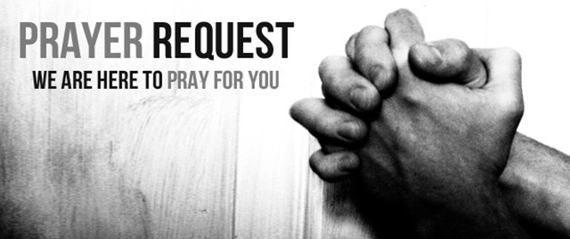

November 7/8, 2020

For those who are sick:

~ Hospitalized: Carl Sattovia *(recovering from heart surgery)*, Larry Lee, grandfather of one of our 3rd grade students; and Jane Stevens-King of our Scout Troop 551

~ For continued healing for Dick Horstmann, Bev Lemen, Dorothy Carroll, Murphy Baker, Judith Hill, Tim Gruenwald, Jerry Eberwein, Bev Bowers, Wilma Jordan, Lana Gieselmann, Doug Neeley , Kerry Horace, Becca Handlang, Terry Crowder, Rick Paul, and Mark and Sandy Ruback

~ For Ray Liszewski, Ingrid Nebel (undergoing tests), Karen Scheer and Norma Hollmann (sister-in-law of Jim and Cindy Hollmann) as they continue their cancer treatments

Bereaved:

Anniversaries/Birthdays:

~ Celebrating birthdays this week: Mike Little (11/8), Michael Hudson (11/10), David Knox (11/11), Todd Reichgert (11/13)

Other:

~ for this week’s designated school families: Dhylan Dunlap (3), Syncir’ Multidor (4), Breyonna Carruth (K), Taylor Wren (1), and Caleb Finley (7)

~ For our men and women in uniform - military, fire and police and our EMS and First Responders; along with doctors, nurses and all workers in the medical field