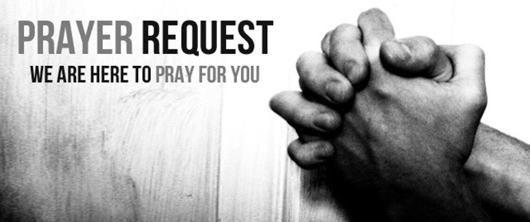

April 10/11, 2021

For those who are sick:

~ Hospitalized: Karen Scheer and Edna Burns

~ for continued healing for Dick Horstmann, Bev Lemen, Dorothy Carroll, Murphy Baker, Judith Hill, Jerry Eberwein, Bev Bowers, Wilma Jordan, Kerry Horace, Elizabeth Edwards, Carlton Nebel, Larry Lee, Lana Gieselmann, and Doug Neely

~for Carlton Nebel, father-in-law of Ingrid Nebel, still dealing with health issues related to COVID

~prayer of thanksgiving for a clean bill of health for Larry Schisler

~ for Ray Liszewski, Ingrid Nebel, Karen Scheer, and Chris Tirmenstein as they continue their cancer treatments

~Hospice Care:

Bereaved:

Anniversaries/Birthdays:

~in celebration of the 40th wedding anniversary of Mike and Kathy Boxdorfer on April 11 and the 33rd anniversary of Bill and Gretchen Gierse on April 16

~for those who celebrate birthdays this week: Tyliah Blanks (4/11) Tyrikk Blanks (4/11), Sarah Busby (4/11), Cha’nelle Barrett (4/13), Josh Fackler (4/15), Rick Knight (4/16), Anthony Krato (4/16) Schuyler Noeth (4/16), Ja’kylah Augustine (4/17) and Linda Prahlow (4/17)

Other:

~for Kim Krato as she deliberates a Call to Teach pre-school at Child of God Lutheran School in St. Peters, MO

~for this week’s Grace Chapel School families: Jeremiah Jadallah (7th), Mack Edwards (5th), and Jayla Jordan (8th)

~ For our men and women in uniform - military, fire and police and our EMS and First Responders; along with doctors, nurses and all workers in the medical field