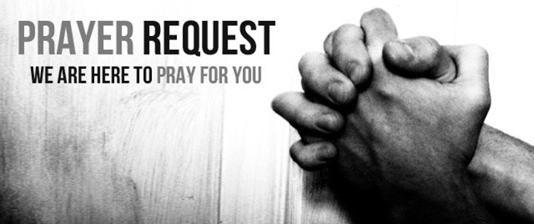

July 11/12, 2020

For those who are sick:

~ Hospitalized:

~ For continued healing for Dick Horstmann, Wayne and Bev Lemen, Dorothy Carroll, Murphy Baker, Judith Hill, Tim Gruenwald, Jerry Eberwein, Bev Bowers, Terry Crowder, Wilma Jordan, Kathy Knight, Lana Gieselmann and Doug Neeley

~ For Ray Liszewski, Ingrid Nebel, Karen Scheer and Norma Hollmann (sister-in-law of Jim and Cindy Hollmann) as they continue their cancer treatments

~ Hospice:

Bereaved:

Anniversaries/Birthdays:

~in celebration of the 7th wedding anniversary of John and Nancy Greene on July 13.

 ~Birthdays this week: Ami Ross (7/13), Pat Schettler (7/14), Kim Krato (7/15), Hannah Crowder (7/16), Bob Gierse (7/16), Chris Knight (7/17), and Kelly Moore (7/18)

Other:

~ For our men and women in uniform - military, fire and police and our EMS and First Responders; along with doctors, nurses and all workers in the medical field