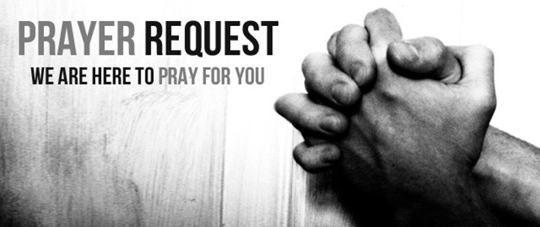

July 17/18, 2021

For those who are sick:

~ Hospitalized:

~ for continued healing for Dick Horstmann, Bev Lemen, Dorothy Carroll, Murphy Baker, Judith Hill, Jerry Eberwein, Bev Bowers, Wilma Jordan, Kerry Horace, Elizabeth Edwards, Carlton Nebel, Larry Lee, Lana Gieselmann, Doug Neely, and Peg Greene *(mother of John and Nancy Greene)*

~ for Ray Liszewski and Ingrid Nebel as they continue their cancer treatments

~Hospice Care:

Bereaved:

Anniversaries/Birthdays:

~for those who celebrate birthdays this week: Kelly Moore (7/18), Fallon Baker (7/19), Mariah Pratt (7/19), Ariana Ross (7/21), Lisa Seldon (7/21), William Liszewski9 (7/22), Lillian Montague (7/23), and Misty Renot (7/24)

Other:

~ for our men and women in uniform - military, fire and police and our EMS and First Responders; along with doctors, nurses and all workers in the medical field