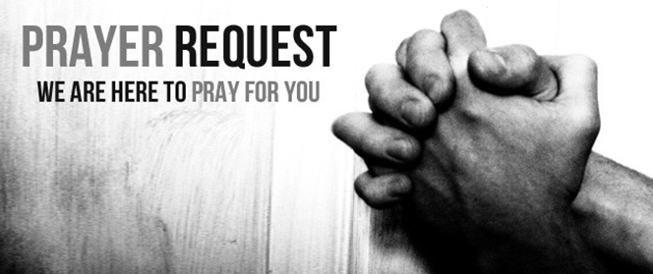

July 24/25, 2021

For those who are sick:

~ Hospitalized:

~ for continued healing for Dick Horstmann, Bev Lemen, Dorothy Carroll, Murphy Baker, Judith Hill, Jerry Eberwein, Bev Bowers, Wilma Jordan, Kerry Horace, Elizabeth Edwards, Carlton Nebel, Larry Lee, Lana Gieselmann, Doug Neely, and Peg Greene *(mother of John and Nancy Greene)*

~ for Ray Liszewski and Ingrid Nebel as they continue their cancer treatments

~Hospice Care: Stanley Euell, father of Rene Hart and grandfather of Kelsey Hart

Bereaved:

Anniversaries/Birthdays:

~in celebration of the 49th wedding anniversary of Bob and Debbie Burkhart on July 29, and the 28th anniversary of Rick and Chris Knight on July 31

~for those who celebrate birthdays this week: Cameron Brown (7/25), Loretta Panhorst (7/25), Edward Weber, Jr. (7/25), Tina Ross (7/26), Renee Hart (7/27), Carl Kleinsorge (7/28), Tim Krato (7/28), Robyn Herr (7/29), Mia Love (7/29), and Pat Kellerhals (7/30)

Other:

~for Pastor Stacy, Andy Fackler and the Youth Group enroute to Camp Linnhaven in North Carolina for their Summer Servant Event. We pray for safe travels and a meaningful experience for all.

~ for our men and women in uniform - military, fire and police and our EMS and First Responders; along with doctors, nurses and all workers in the medical field