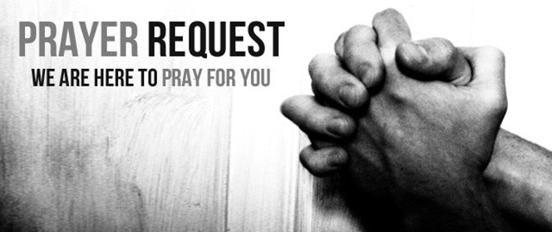

September 26/27, 2020

For those who are sick:

~ Hospitalized: Terry Crowder

~ For continued healing for Dick Horstmann, Wayne and Bev Lemen, Dorothy Carroll, Murphy Baker, Judith Hill, Tim Gruenwald, Jerry Eberwein, Bev Bowers, Wilma Jordan, Lana Gieselmann, Doug Neeley and Rick Paul

~ For Ray Liszewski, Ingrid Nebel, Karen Scheer and Norma Hollmann (sister-in-law of Jim and Cindy Hollmann) as they continue their cancer treatments

Bereaved:

Anniversaries/Birthdays:

~in celebration of the 58th wedding anniversary of Ray and Fran Liszewski on September 29 and the 26th anniversary of Jim and Sheryl Borgmann on October 1.

~ Celebrating birthdays this week: Tim Gruenwald (9/28), Jeff Renot (9/28), Sammi Weir (9/28), Wilma Jordan (9/29), Debbie Mayes (9/29), Jonathan Kersten (9/30), Rayonna Pollvogt (9/30), Beverly Bowers (10/1), Ruth Luhrsen (10/1), Eric Brofford (10/2), Ty Koly (10/2), Andrew Tirmenstein (10/2), Shelby Terrell (10/3)

Other:

~ For our men and women in uniform - military, fire and police and our EMS and First Responders; along with doctors, nurses and all workers in the medical field