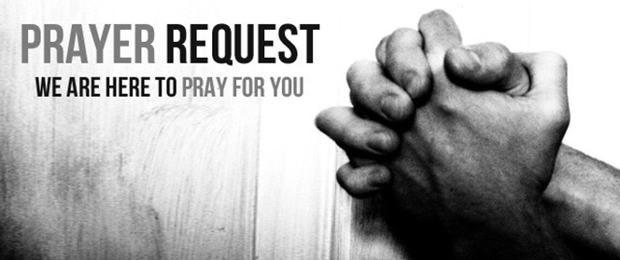

May 17, 2020

For those who are sick:

~ Hospitalized: Wilma Jordan

~for Mike Kratzer’ aunt, Marcene, who is hospitalized in Maryland with a blood infection and kidney issues

~ For continued healing for Dick Horstmann, Wayne and Bev Lemen, Dorothy Carroll, Murphy Baker, Judith Hill, Tim Gruenwald, Jerry Eberwein, Jacob Roeglin, Bev Bowers, and Terry Crowder

~ For Mark Ruback, Don Roth, father of Mike Roth; Ray Liszewski, Ingrid Nebel, Karen Scheer and Norma Hollmann (sister-in-law of Jim and Cindy Hollmann) as they continue their cancer treatments

~ Hospice: Pat Burns, son of Edna Burns

Bereaved:

~For the family of Dorothy (Dolly) McFerron called to rest on May 7.

Anniversaries/Birthdays:

~in celebration on the 69th wedding anniversary of Wayne and Bev Lemen on May 19 and the 11th wedding anniversary of Eric and Amy Brofford on May 23.

~Celebrating birthdays this week: Fran Liszewski (5/18), Jim Prahlow (5/18), Clarence Williams (5/21), John Kersten (5/22)

Other:

~The LAMP Mission team would like to heartily thank the anonymous donor who made a generous contribution towards funding LAMP missions. Thank the Lord for His provision!

~for all our Grace Chapel school students and families

~ For our men and women in uniform - military, fire and police and our EMS and First Responders; along with doctors, nurses and all workers in the medical field