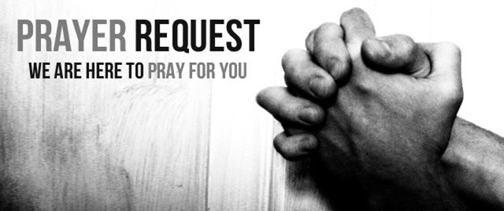

August 29/30, 2020

For those who are sick:

~ Hospitalized:

~ For continued healing for Dick Horstmann, Wayne and Bev Lemen, Dorothy Carroll, Murphy Baker, Judith Hill, Tim Gruenwald, Jerry Eberwein, Bev Bowers, Terry Crowder, Wilma Jordan, Lana Gieselmann, Doug Neeley and Rick Paul

~ For Ray Liszewski, Ingrid Nebel, Karen Scheer and Norma Hollmann (sister-in-law of Jim and Cindy Hollmann) as they continue their cancer treatments

Bereaved:

Anniversaries/Birthdays:

~ In celebration of the 25th wedding anniversary of Jim and Lynn Sheehan on September 2 and Larry and Elaine Schisler on September 5

~ Celebrating birthdays this week: Brianna Drake (9/1), Jim Schneider (9/2), Faith Borgmann (9/3), Tony Busby (9/3), David Drewes (9/3), Judy Gibson (9/3), Isabella Gehner (9/4), Diane Roche-Hampton (9/4), Andrew Bolstad (9/5), Kim Hastings (9/5)

Other:

~ For our men and women in uniform - military, fire and police and our EMS and First Responders; along with doctors, nurses and all workers in the medical field