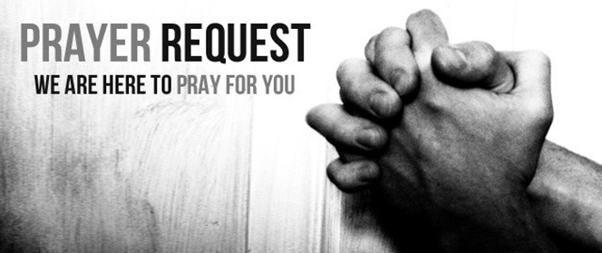

November 14/15, 2020

For those who are sick:

~ Hospitalized: Larry Lee, grandfather of one of our 3rd grade students

~ For continued healing for Dick Horstmann, Bev Lemen, Dorothy Carroll, Murphy Baker, Judith Hill, Tim Gruenwald, Jerry Eberwein, Bev Bowers, Wilma Jordan, Lana Gieselmann, Doug Neeley , Kerry Horace, Becca Handlang, Terry Crowder, Rick Paul, Mark and Sandy Ruback, and Carl Sattovia

~ For Ray Liszewski, Ingrid Nebel, Karen Scheer (undergoing tests), and Norma Hollmann (sister-in-law of Jim and Cindy Hollmann), and Dennis Jordan as they continue their cancer treatments

~Hospice Care: Patricia Kneemueller, mother of Jolene Borgmann

Bereaved:

Anniversaries/Birthdays:

~in celebration of the 46th wedding anniversary of Stan and Karen Scheer on November 16

~ Celebrating birthdays this week: Xavier Jones (11/15), Hannah Lanning (11/18), Brett Ritchey (11/18), Aaron Whitner (11/18) and Jean Hawkins (11/19)

Other:

~ for this week’s designated school families: Nevaeh Boston (Kind.), Lauryn Freeman (Pre-S.), Laci Freeman (3), Nylah Griffin (1) and Charlotte Evans (Kind.)

~ For our men and women in uniform - military, fire and police and our EMS and First Responders; along with doctors, nurses and all workers in the medical field