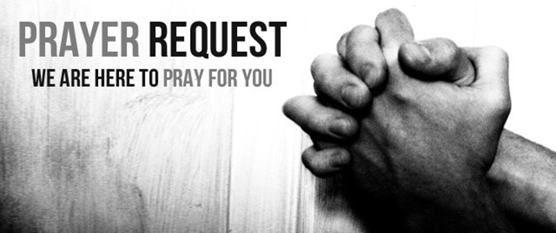

May 10, 2020

For those who are sick:

~ Hospitalized: Wilma Jordan

~for Mike Kratzer’ aunt, Marcene, who is hospitalized in Maryland with a blood infection and kidney issues

~ For continued healing for Dick Horstmann, Wayne and Bev Lemen, Dorothy Carroll, Murphy Baker, Judith Hill, Tim Gruenwald, Jerry Eberwein, Jacob Roeglin, Bev Bowers, and Terry Crowder

~ For Mark Ruback, Don Roth, father of Mike Roth; Ray Liszewski, Ingrid Nebel, Karen Scheer and Norma Hollmann (sister-in-law of Jim and Cindy Hollmann) as they continue their cancer treatments

~ Hospice: Pat Burns, son of Edna Burns

Bereaved:

Anniversaries/Birthdays:

 ~Celebrating birthdays this week: Jamie Moore (5/11), Leslie Pollvogt (5/13), Cynthia Knighten (5/16), Rachel Moldovan (5/16), Libbie Vierdag (5/16)

Other:

~for all our Grace Chapel school students and families

~ For our men and women in uniform - military, fire and police and our EMS and First Responders; along with doctors, nurses and all workers in the medical field