Getting to Know AWANA
Parent Guide
2019-2020 School Year
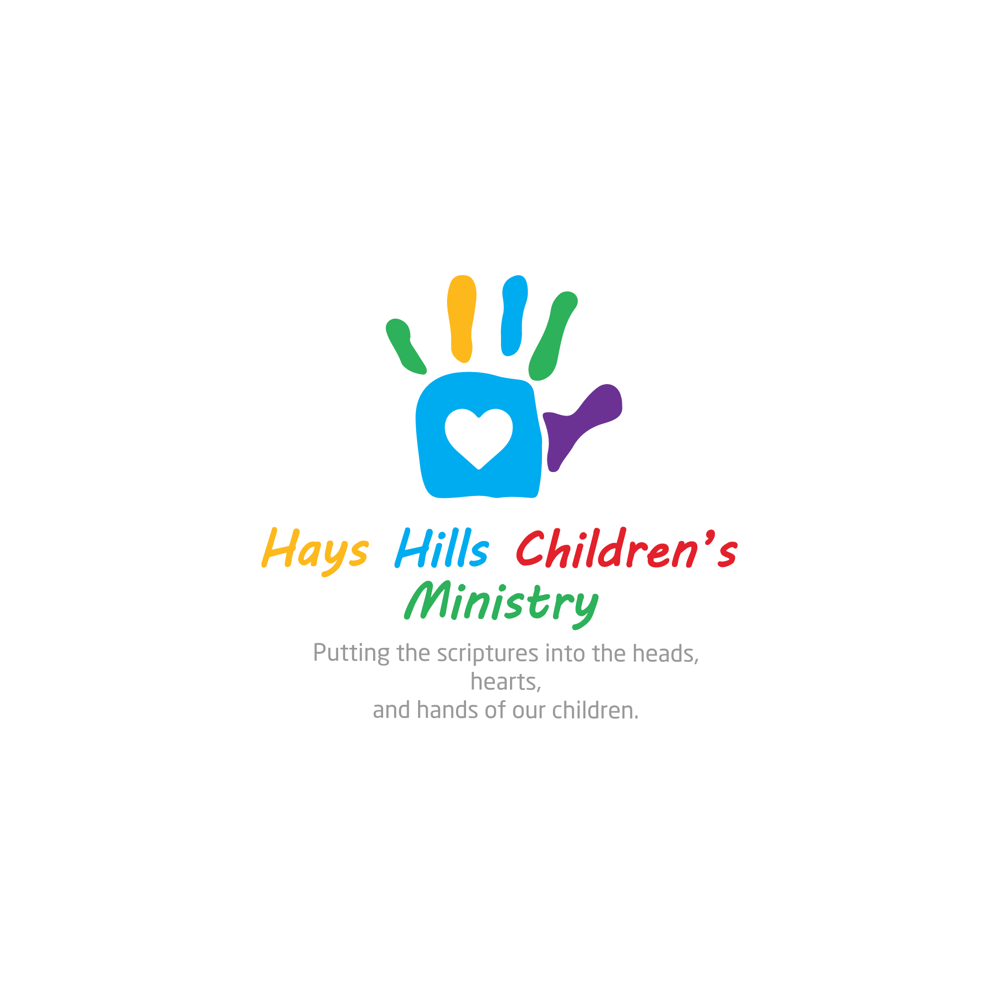

What is the schedule?
Cubbies (Pre-K)
- 6:45-6:50 Check-in
- 6:53-7:13 Handbook Time
- 7:15-7:35 Play Time
- 7:38-7:58 Large Group Time
- 8:00-8:10 Closing / Announcements / Awards
Sparks (Kindergarten – 2nd Grade)
- 6:45-6:50 Check-in
- 6:53-7:13 Handbook Time
- 7:15-7:35 Sparks Game Time
- 7:38-7:58 Large Group Time
- 8:00-8:10 Closing / Announcements / Awards C-6
Truth & Training (3rd – 5th Grade)
- 6:45-6:50 Check-in
- 6:53-7:13 Large Group Time
- 7:15-7:35 Handbook Time
- 7:38-7:58 Game Time
- 8:00-8:10 Closing / Announcements / Awards Building A
Where do I drop off and pick up?
- Cubbies are dropped off and picked up in their classrooms in building D
- Kindergarteners are dropped off in their classrooms in building C and picked up in building C room 6.
- Sparks are dropped off in building A and picked up in building C room 6.
- T&T is dropped off and picked up in Building A.
Are there fees for attending AWANA?
- Dues are $15.00/semester
- Uniforms (vests and jerseys) are $10 each.
- Dues are intended to offset the cost of handbooks, awards, and other AWANA expenses. It is requested that each clubber pay dues if able. We do not want dues to keep any child out of AWANA and as such they are not required.

What is Handbook Time?
- Handbook time seeks to lay a foundation of faith in your child’s life through the memorization of God’s word. It is during this time that each clubber can recite memory verses to their leaders and then discuss what these verses mean.
- Handbook time is most profitable to your child if they come prepared to recite their sections. We encourage you to work with your child throughout the week to help them memorize their sections.
- Each child begins in an entrance booklet that can be completed in two or three weeks. Once your child completes his/her entrance booklet, they earn an AWANA uniform, full handbook, and awards for achievement.
- The goal is for each clubber to complete one handbook each year. The handbooks have sections designed to complete 1 section per week to achieve the goal. Handbook time is self-paced. Everyone can work on as many sections as they want to each week.
- For a section to be completed, it must be recited all at once. Verses must be memorized word perfect. Clubbers are allowed only two helps per section.
  - A help is when a Handbook Leader tells a clubber a word or phrase to aide them in reciting their verse.
What is Large Group Time?
- Large group is a time where clubbers gather together to learn about the Bible, Christian doctrine, and Christian practice.
  - 3 themes will be covered with the children during each semester. We spend 4 to 6 weeks covering each teaching theme. Theme 1 covers material from the AWANA handbooks. Fall semester, theme 2 cover the Bible (every fall semester will cover “What is the Bible?” since the scriptures are central to Christian life and practice). Spring Semester, theme 2 covers how to live like a Christian; lessons rooted in Don Whitney’s book Spiritual Disciplines for the Christian Life. Theme 3 covers Christian beliefs at an age appropriate level from Wayne Grudem’s book Christian Beliefs. The lessons for themes 2 and 3 rotate in a 3-year cycle.
    - Year one: Theme 2 – Fall = What is the Bible? Spring = How to Pray
    - Year one: Theme 3 – Fall = Who is God? Spring = Who is Man?
    - Year two: Theme 2 – Fall = What is the Bible? Spring = How to Study the Bible
    - Year two: Theme 3 – Fall = What is Sin? Spring = Jesus’ Life, Death, Resurrection, and New Creation
    - Year three: Theme 2 – Fall = What is the Bible? Spring = How to Share Our Faith
    - Year three: Theme 3 – Fall = What is the Church? Spring = What are Angels, Satan, and Demons

What is Game Time?
- Game time gives clubbers an opportunity to burn off some energy! It also builds Christian fellowship, good sportsmanship, and team spirit. Although the games are competitive in nature and winning is desirable, leaders are encouraged to give top priority to building and preserving team work.
What is Award Time?
- During this time, adult leaders will make announcements, and give awards that have been earned that evening to clubbers.
What are the awards?
- Each handbook has awards for groups of sections completed. Sparks wear a vest on which they add patches, pins and jewels. T&T has a jersey shirt on which they add patches as they complete groups of sections. There are also awards for completing whole books.
What are AWANA Bucks and how does my child earn them?
- AWANA bucks are like money that we give out as awards. Once each semester we will have an AWANA store. The store will be filled with items the children can purchase with AWANA bucks. Children earn bucks by earning points for various activities during AWANA (see list below). For every 3300 points a child earns, they get 1 AWANA buck.
  - Attending Club - 100pts
  - Bringing Bible - 200pts
  - Bringing Handbook - 200pts
  - Attending Bible Life Group - 400pts
  - Attending Children's Worship - 400pts
  - Attending Children’s Choir - 200pts
  - Participating in Theme Night - 200pts
  - Wearing Uniform - 200pts
  - Completing Sections - 800pts each
  - Game Time
    - 1st place team - 300pts
    - 2nd place team - 200pts
    - 3rd place team - 100pts
    - 4th place team - 100pts
  - “Caught Being Good”
    - Bracelets given to children who are focused on serving others and exemplifying appropriate behavior. At Closing Ceremony these children will be recognized, and their bracelets will be exchanged for an AWANA buck.
What are theme nights?
- Each week, we have a different theme, e.g. whack hair night. You are not obligated to participate, but it is very fun! We send reminders of the week’s theme on Facebook and our HHCM parent email list.

If you have any questions, please call or email our Children’s Minister, Ethan Graves.
512-749-9282 // ethan@hayshills.com

