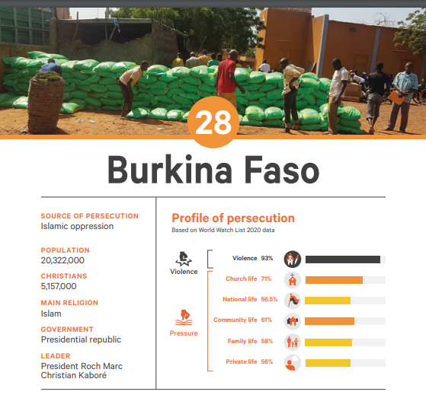

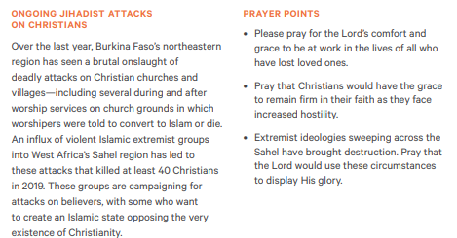





Prayer Requests

MISSIONARIES: Matt and Deborah Stanghelle

1. The Stanghelles have landed!  We landed safely in Stavanger on the 17th after a brief layover in Amsterdam. The children handled the journey like champs.  The family of our colleague, Jonas Stava, lives on the island of Karmoy, north of the city, and they have graciously allowed us to live in one of their rental properties until the church is registered and we receive our visas. Once we receive our visas we will relocate to Stavanger.

2. Please pray for Deborah's eye.  She developed a case of iritis before leaving Minnesota, which is now improving. Please pray for full recovery.

3. We plan to begin private worship services soon with a public launch later in the year. Pray that God would continue to nurture and multiply our core group. We also have several American team members that are attempting to move to the city in the months ahead. Pray that God would open the door for them to come. Lastly, please pray for me as I layout the sermon and teaching schedule for these early days.

4. A potential rental space for the church and office has opened up in the Hinna district of Stavanger. Hinna affords us a central location in the city very close to the NATO base and the university. Pray that God would give us great favor in getting the space, by 10:30 a.m. on Sundays as well as favorable rental rates for the two spaces. This is the only place in Hinna that would consider renting to a religious group. Please pray fervently for this need.

5. The first parcel we received from America happened to be the first batch of our church psalters! We will use the Book of Psalms for Worship as our psalter and for hymns we will use the Trinity Hymnal. The later has yet to be ordered. Please pray that the word of Christ would dwell in us richly as we sing his glory in the Psalms.

6. We received notice on Sept. 30 that the church is officially registered. For the first time in history, there is a Presbyterian Church in Norway!  This means that we can apply for our visas much sooner than we anticipated. Please pray for the next step which will be setting up an appointment for an interview at the local police station. Pray for the opportunity to interview in the next week or two.

7.  We still have need for annual and monthly financial partners. Please join us in praying for several more individuals, families and churches to join our gospel patron’s team.

**Unreached People Group**

**Jula (Dyula) in Burkina Faso**

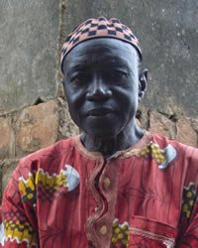

The Jula of Burkina Faso primarily live along the trade routes in the southwestern part of the country. The name dyula means "itinerant trader," and the Jula (Dyula) are respected for their trading abilities. The Jula live in clans, and the clan is the most important aspect of their lives. The people are fiercely loyal to their clans, defending them proudly. The majority of Jula are Sunni Muslim. Most of the others, whom the Muslims call pagans, hold traditional animistic beliefs (believe that non-living objects have spirits).

**PRAY:**

**\*For the Lord of the harvest to send forth laborers into Burkina Faso to live and work among the Jula.  
*For God to raise up prayer teams who will begin breaking up the spiritual soil through worship and intercession.  
*For God to anoint the Gospel as it goes forth via radio to the Jula.  
*For the effective use of the Jesus film and other evangelistic materials in the Jula language.  
* Ask the Lord to bring forth a strong and grow**

**Unreached People Group**

**Jula (Dyula) in Burkina Faso**



The Jula of Burkina Faso primarily live along the trade routes in the southwestern part of the country. The name dyula means "itinerant trader," and the Jula (Dyula) are respected for their trading abilities. The Jula live in clans, and the clan is the most important aspect of their lives. The people are fiercely loyal to their clans, defending them proudly. The majority of Jula are Sunni Muslim. Most of the others, whom the Muslims call pagans, hold traditional animistic beliefs (believe that non-living objects have spirits).

**PRAY:**

**\*For the Lord of the harvest to send forth laborers into Burkina Faso to live and work among the Jula.  
*For God to raise up prayer teams who will begin breaking up the spiritual soil through worship and intercession.  
*For God to anoint the Gospel as it goes forth via radio to the Jula.  
*For the effective use of the Jesus film and other evangelistic materials in the Jula language.  
* Ask the Lord to bring forth a strong and growing Jula church** for the glory of His name!