Week 5, Joshua 6 Hook
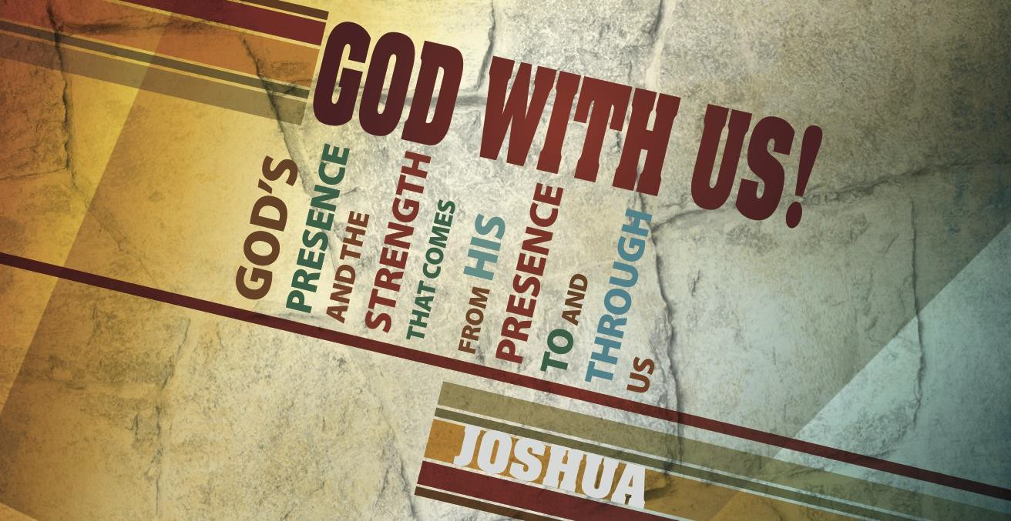

Main Point: God provides victory over strongholds.

Current Event: Today’s lesson focuses on God’s intervention in the battle of Jericho and His unconventional strategy. Imagine that you are tasked with accomplishing a challenging goal and could choose five individuals to help you. Break your class into small groups and provide them with one or more of the following scenarios. Ask the groups to choose five individuals (historical or fictional) to aid them in their task. When your class small groups have chosen five individuals, encourage the groups to share their reasoning.
Scenarios:

- You are running for President of the United States of America. What five individuals would you choose to help you win the seat?
- You must break into the Fort Knox Bullion Depository (arguably the most secure building on the planet). What five individuals would you choose to assist you?
- Your city has been attacked and occupied. You are tasked with assembling a resistance force to overthrow the invaders; what five individuals do you tap for the team?

Joshua 6 Book

Main Point: God provides victory over strongholds.

Text Summary: Israel conquers the walled city of Jericho after obeying a battle plan authored by the LORD for His glory and their joy. With the merciful exception of Rahab and her household, the entire city was destroyed as a holy offering.

Joshua 6:1–16 (Read)
Sub Point: Walk in obedience with expectancy while waiting on the Lord.

The account of Joshua’s battle at Jericho is one of the most well-known stories in Old Testament literature. It continues to encourage God’s children that, though we are weak, we are strong. His presence is the true strength of a people, not skill, horses or armed men. Israel is the underdog about to fight a strong enemy.
Jericho is one of the geographically lowest cities on earth (750 feet below sea level), one of the oldest cities, and one of the earliest cities to fortify. Notably, Jericho is spring-fed and referred to as the “city of palms” in Judges 1:16.¹ However, despite its strength and resources, Jericho is trembling. Rahab’s account of the terror that has gripped the people is fleshed out in the first verses of Joshua 6. The city has shut its gates. Jericho is closed for business in anticipation of
Israel’s siege.
Joshua and the Commander of the Lord’s Army stand outside of Jericho’s gates and discuss the battle plan. In his communication with Israel’s leader, the LORD encourages Joshua saying “See, I have given Jericho into your hand” (v. 2). The Bible Knowledge Commentary describes the language used:
The tense of the Hebrew verb is prophetic perfect (I have delivered), describing a future action as if it were already accomplished. Since God had declared it, the victory was assured.²
Imagine Joshua’s position. At this point in life, Israel’s leader was an experienced warrior and commander. The warrior was told that he would not be using any battering rams or scaling tools to either destroy or climb the walls. The unconventional plan instead instructed seven priests to blow seven trumpets continuously before the ark of the Lord. Warriors would march before the priests and after the ark. No one would speak. This would continue for six days and

¹ Crossway Bibles, The ESV Study Bible (Wheaton, IL: Crossway Bibles, 2008), 401
² Donald K. Campbell, “Joshua,” in The Bible Knowledge Commentary: An Exposition of the Scriptures, ed.
J. F. Walvoord and R. B. Zuck, vol. 1 (Wheaton, IL: Victor Books, 1985), 340.

on the seventh, after the trumpet sounds, the people would shout and see the destruction of the wall.
Instruments of worship, not warfare, are the items highlighted in these verses. The Ark of the Covenant was a unique reminder of God’s presence. Hebrews 9:4–5 shares that the contents of the ark were as follows: the Ten Commandments, a jar of manna and Aaron’s rod. The Ten Commandments were of significant consequence. Romans 3:20 states: “For by works of the law no human being will be justified in his sight, since through the law comes knowledge of sin.” The Law did not save but instead made God’s people aware of their sin. Thankfully, the ark also featured the Mercy Seat. The Mercy Seat was where God would meet with His people. Each year on the Day of Atonement, the High Priest would make a blood sacrifice, sprinkling the blood on the Mercy Seat. This sacrifice was to atone for the sins of the people, for their shortcomings in not living up to the law (Exodus 30:10). The Ark of the Covenant reminded the people of God’s presence, holiness, power and provision.
The other items of note involved in the siege were trumpets. These were no ordinary trumpets; they were “jubilee trumpets” and were instruments used during solemn feasts. The blowing of these horns reminded God’s people of His presence and His connection to His people.
The Commander of the Lord’s Army spoke nothing to the protection of those circling Jericho or to the involvement of the forces. Instead the plan focused solely on the power and participation of God himself.
Joshua teaches us that a spiritual battle is the only battle won by surrender. He and Israel did not have to exert effort to win, but only to obey and to praise the God who gave Joshua a step- by-step battle plan. That plan began with this promise: “See, I have given Jericho into your hand” (6:2). Because God’s language proved victory over Jericho was a done deal, Joshua executed the remaining details with trusting obedience:
- Form a processional: all people behind the Ark of the Covenant, the ark behind the priests blowing rams’ horns, and the priests behind the armed men.
- March around the city once a day for six days making no sound except the trumping of horns.
- On the seventh day, march around the city seven times and shout while the priests blow the trumpets in one final blast, but only after Joshua gives the signal.
Can obedience be a form of worship? How?

How do Joshua and the battle of Jericho teach us that a spiritual battle is won by surrender? At what points in these verses (1–16) do you see evidence of surrender?
In 6:16 Joshua declared the LORD’s promise before he saw it come to pass. What are some Scripture promises that you have declared or want to begin declaring?

Joshua 6:17–27 (Read)
Sub Point: Recognize God’s provision in victory.

Joshua gives the command: “Shout, for the LORD has given you the city.” This is the exciting part, the portion of the story that is memorized by children and held up as an encouragement for believers who are fighting a stronghold in life. However, the instructions in verses 17–19 are just as significant: Keep nothing for yourselves, this victory and its spoils belong to God. Donald Campbell explains the significance of the devotion of Jericho to the LORD:
The contents of Jericho were to be given “to the LORD” as the firstfruits of the land. Just as the firstfruits of a crop, given to the Lord, pointed to more crops to come, so the conquest of Jericho signified that Israel would receive all of Canaan from Him.³
The word in verse 17 translated as “devoted” comes from the verb haram and the noun herem. The words can carry meanings of “devoted,” “devoted things,” “to devote to destruction” or “to completely destroy.” When someone destroys something that has been devoted, that offering is without the possibility of being revoked. If the city were destroyed in devotion, there would be no chance that the Israelites would be tempted to claim it for themselves. Verse 18 explains that if items that had been devoted to the LORD were taken into Israel’s camp, then those, too, would become subject to destruction.⁴
A reader cannot help but notice the few words devoted to the actual battle of Jericho. Verses 20 and 21 briefly describe the action: The priests blew the horns; the people shouted; the wall fell; the Israelites entered and devoted all in the city to destruction. The majority of the page’s real estate is given to the preparation and follow-up of taking the city. Scripture leaves out the details of the battle; this aids the reader in understanding that the battle belonged to the LORD, it was effortless for Him. The focus for the people would be faithfulness in God’s ability and obedience to His commands.⁵
The city was destroyed but, as promised, Rahab and her family were spared. Verse 23 explains that she and her family were kept outside of the camp of Israel, a period of spiritual quarantine.⁶ Rahab’s faith motivated her to action and she was shown mercy. Her story would continue in an extraordinary genealogy: Ruth was the mother of Boaz, Boaz the great grandfather of David, David the ancestor of Jesus.

³ Donald K. Campbell, “Joshua,” in The Bible Knowledge Commentary: An Exposition of the Scriptures, ed.
J. F. Walvoord and R. B. Zuck, vol. 1 (Wheaton, IL: Victor Books, 1985), 341.

⁴ Howard, p. 173
⁵ ibid., 175
⁶ Moody, p. 324

Joshua promised trouble for the one who attempted to rebuild Jericho. This curse was later seen realized by Hiel the Bethelite in 1 Kings 16:34.
Finally, the last paragraph focused the reader’s attention on the cause for Joshua’s success: the LORD was with him. The Almighty won the victory at Jericho that day; Joshua’s role was to act in faith and obedience.
Jericho was a firstfruits of Canaan. Why is it significant that believers give back to God?

What strongholds has the LORD destroyed in your life? How did your faith grow through the process?
What lessons can be learned from Rahab’s story? What encouragement can be drawn from her inclusion in the lineage of Jesus?

Week 5, Joshua 6 Took

Main Point: God provides victory over strongholds.

In Today’s Culture: Remind the class of the teams they chose in the Hook exercise. Ask your class to describe the significance of the “team” God assembled in the siege of Jericho.

Lesson Conclusion: The LORD provides victory where man cannot. In light of a seemingly insurmountable obstacle (the walls of Jericho) the people of Israel were called to an unconventional set of behaviors; these actions required belief and submission. After being handed victory, the young nation was commanded to recognize God’s provision by surrendering the city and everything in it to Him.

Challenge:

Be silent. The people marched around Jericho in silence: watching, waiting and demonstrating obedience. Have you lost your patience? Have you refused to be silent and obedient while waiting for deliverance from God? Just as Joshua and the people of Israel, determine quietly, watch, wait, and expectantly walk in obedience as God moves.
Present your strongholds to God. The apostle Paul redefines a physical stronghold for us in spiritual terms:
“For the weapons of our warfare are not of the flesh, but have divine power to destroy strongholds. We destroy arguments and every lofty opinion raised against the knowledge of God, and take every thought captive to obey Christ” (2 Corinthians 10:4–5, emphasis added).
The strongholds of our warfare are more often thoughts of the heart than of the head. A heart thought is a belief. When our heart believes something that is contrary to His Word, it is a misbelief. Only the active and living Word of the LORD is able to reveal the thoughts of our heart (Hebrews 4:12). So ask Him to reveal any lies you believe about God, yourself and others.

Praise God in victory. Invite friends and family to find shelter in the household of faith before the final trumpet blast. Share the Gospel! Write down the names of people you feel must hear the news of God’s imminent return.

