Week 9, Joshua 20 & 21 Hook
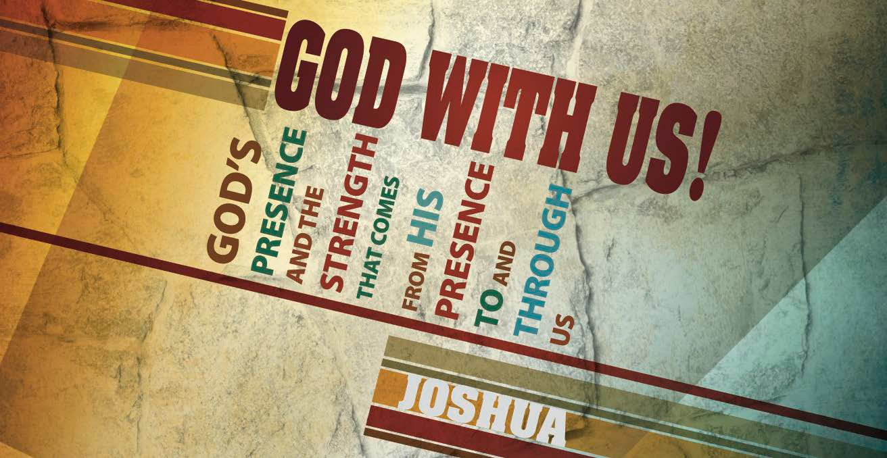

Main Point: God’s presence brings mercy and provision.

Current Event: Where do you find your sense of security? According to the Bureau of Justice, an average of 3.7 million burglaries occurred annually between the years 2003 and 2007. A household member was home during the crime about 28 percent of the time.¹ Statistics like these often encourage home owners to purchase security systems; while most Americans would invest in a simple security package that utilizes sensors and a direct line to help, there are more sophisticated options available. In a CNBC article, a security company that caters to the wealthy shared some of the tools they have installed in ultra-expensive homes:
- Shotgun panels – These weapons are hidden behind wall panels and ceilings. When activated, each array shoots 15 shotgun shells.
- Fog blast – The fogger emits air that is laced with pepper spray or a sleeping compound.
- Heliport – In need of an aerial getaway? For around $100,000 you, too, could install a landing pad on your home.²
Today’s lesson explores God’s provision and mercy as He grants security to those in need.

Discussion Questions

¹ http://www.bjs.gov/content/pub/pdf/vdhb.pdf
² http://www.cnbc.com/2012/06/06/Billionaire-Security:-Ultimate-Protection-Measures.html?slide=13

What measures have you taken in an effort to secure your home? What role does the feeling of security play in our lives?
How has God protected you in the past? How is God protecting you today?

Week 9, Joshua 20 & 21 Book

Main Point: God’s presence brings mercy and provision.

Text Summary: The promise of land conquest and distribution are fulfilled after final provisions are made for two groups of people: the innocent and the priesthood. Chapter 20 tells of Israel’s allocation of cities of refuge for those who accidentally kill another and chapter 21 denotes the allocation of levitical cities across the country for Levi’s descendants.

Joshua 20 (Read)
Sub Point: God’s offer of mercy and safety extends to all.

Moses received clear instructions from the Lord regarding murder:

“Whoever strikes a man so that he dies shall be put to death. But if he did not lie in wait for him, but God let him fall into his hand, then I will appoint for you a place to which he may flee. But if a man willfully attacks another to kill him by cunning, you shall take him from my altar, that he may die” (Exodus 21:12–14).
Moses shares these instructions with the people in Deuteronomy 19 and, here, in chapter 20 Joshua ensures the command is carried out. It is a powerful reminder that everything Joshua did was by the word of the Lord.
The cities of refuge are designed to protect the innocent. After the land allotment, Joshua now establishes these cities for the people of Israel, and elsewhere. The establishment of these cities shows God’s mercy.³ Not only did it show God’s mercy, it prevented more innocent blood from spilling. How so? The passage speaks of two people: the man who innocently killed another, the manslayer, and the man who now is hunting the offender, seeking restitution, the avenger of blood.
The avenger of blood mentioned in this passage, and only seen in a total of four texts in the Old Testament, seeks compensation for the loss of life.⁴ A more general description, found more than 50 times, is translated as close relative, or kinsman redeemer.⁵ This law listed in Leviticus 25 discloses the parameters for regaining family property. They are seeking to make things right, to bring justice. But what God does through these cities is keep order and bring balance to His law. Because of the cities of refuge, under the law, the avenger was not allowed to exact

³ Howard, David [1998] New American Commentary: Joshua. Nashville: B&H Publishers, p. 379
⁴ Hess, Richard [1996] Tyndale Old Testament Commentary: Joshua. Downers Grove: IVP Academic, p. 306
⁵ Howard, David [1998] New American Commentary: Joshua. Nashville: B&H Publishers, p. 379

private vengeance.⁶ The avenger was unable to carry out justice the way he saw fit. The guilty one was allowed a trial. This kept God in His place and man in his; as Deuteronomy 32:35 explains, vengeance belongs to the Lord alone.
There is an interesting provision in Joshua 20:6: the innocent must remain in the city until the death of the current high priest. The intricacies of the prescribed laws in relation to the cities of refuge are massively symbolic. You see, the priest of the city represents the nation, especially in terms of its guilt and its sacrifice.⁷ More importantly, the offender is allowed to leave upon the death of the priest because the priest’s death symbolically terminates the guilt incurred.⁸ At this time, the manslayer may return to his own town and home.
Once this happens, the avenger of blood stops his pursuit. No more hunting because the priest’s death serves as payment, a form of substitute, for the offended party.⁹ For the Christian, this picture is a depiction of Christ, whose death took away the guilt of our sin.
Deuteronomy 19:2–4 explains that these safe havens were to be centrally located, with roads made for easy access.¹⁰ Three on the east side of the Jordan River and another three along the west side, all evenly distributed from north to south.
Just as these towns were open to anyone, with the accompanying mercy and safety, so, too, is the mercy and protection offered in Christ.
We see Psalm 61:1–4 allude to these cities and how we have a safe place to hide, even to this day:
“Hear my cry, O God, listen to my prayer;

from the end of the earth I call to you when my heart is faint. Lead me to the rock that is higher than I,
for you have been my refuge, a strong tower against the enemy. Let me dwell in your tent forever!
Let me take refuge under the shelter of your wings!”

⁶ Howard, David [1998] New American Commentary: Joshua. Nashville: B&H Publishers, p. 382.
⁷ Hess, Richard [1996] Tyndale Old Testament Commentary: Joshua. Downers Grove: IVP Academic, p. 306
⁸ Ibid.
⁹ Ibid., 307
¹⁰ Longman III, Tremper and David E. Garland, [2012] The Expositor’s Bible Commentary, Revised Edition: Numbers- Ruth, Grand Rapids: Zondervan, p. 1014.

It is a beautiful promise of the spiritual refuge we have in Christ, our strong tower, our safe refuge.
What do these cities of refuge say about the character of God?

In what ways do you see Christ’s work foreshadowed in the high priest’s death on behalf of the manslayer?
Ponder Psalm 61:1–4. We do not run to a physical city of refuge today; how do we enter the safe place?

Joshua 21:1–3 and 43–45 (Read) Sub Point: God is faithful.

“But to the tribe of Levi Moses gave no inheritance; the Lord God of Israel is their inheritance, just as he said to them” (13:33).
The Levites do not receive an allotment of land because the Lord is their lot and portion. Yet, every tribe in Israel is to reserve cities in which the Levites can live, minister, and prosper.
Joshua 21 designates 48 Levitical cities. The Levites’ job was to teach the Law. Having these 48 cities scattered throughout the land made that possible.¹¹
With the allotment of land to the Levites, three major themes arise from chapter 21:¹²

- The nation of Israel obeyed the Lord.
- The nation of Israel looked after God’s servants.
- The nation of Israel functioned as a unit.

The final verses of Joshua 21 are a sweeping summary of the great work God did in fulfilling His promises. This conclusion showed that nothing God willed failed. All that He governed came to pass. Nothing in His provision was lacking. Not one of Israel’s enemies was victorious. God was faithful. This conclusion shows a historical fulfillment. This narrative in Joshua shows that the promises God made to the patriarchs, that the land would belong to their descendants, had come to pass throughout Joshua.¹³ We see that all the land God promised has been given. All the enemies that came against Israel have been defeated. And all the promises God made to their forefathers have come to pass.

¹¹ Howard, David [1998] New American Commentary: Joshua. Nashville: B&H Publishers, p. 387.
¹² Ibid., 391
¹³ Hess, Richard [1996] Tyndale Old Testament Commentary: Joshua. Downers Grove: IVP Academic, p. 312.

Scholars show that structurally, this three-verse conclusion to chapter 21 summarizes everything in the book that has come before it.¹⁴ Verse 43, which speaks of the land given and settled, summarizes chapters 13–21. Verse 44, which speaks of conflict with Israel’s enemies, sums up chapters 1–12. And finally, verse 45 sums up chapters 22–42.
Joshua knew that struggles would come. Despite people’s faithlessness, stories like Joshua’s must be told. They remind us of what matters most—God is faithful and His promises are sure.
Read Joshua 21:43–45. What image(s) of the theme of land/rest/fulfillment is/are conjured for you as a New Testament believer?
Consider that the Levites did not receive an allotment of land. How does someone begin to view Jesus as his lot and portion? Describe a time in your life when you were denied something that you desired; how did this experience bring you closer to the Lord?

¹⁴ Howard, David [1998] New American Commentary: Joshua. Nashville: B&H Publishers, p. 397.

Week 9, Joshua 20 & 21 Took

Main Point: God’s presence brings mercy and provision. Group Activity:
Play a recording, sing together as a class, or examine the printed lyrics of the hymn God Will Take Care Of You. Challenge your class to express their thankfulness and rest assured that God sustains His children.
Be not dismayed whate’er betide, God will take care of you!
Beneath His wings of love abide, God will take care of you!

God will take care of you,
Through every day o’er all the way; He will take care of you;
God will take care of you!

Lesson Conclusion: God’s gift of land ensured justice for the vulnerable. This begs the question: How can we ensure justice for the vulnerable? God cares for His people, provides for His people, makes assurances for His people, and (as we see in 21:43–45) the Lord is ever and always faithful to His people.

Challenge

Trust that God will take care of you. Release your stresses to God. Christ is sincerely concerned for your welfare and will provide. The same God who has allowed you to walk though hardships and trials is the same God who will sustain you through them.

Humble yourselves, therefore, under the mighty hand of God so that at the proper time he may exalt you, casting all your anxieties on him, because he cares for you (1 Peter 5:6–7).

Thank God for mercy in your words and deeds. Consider the picture of God’s mercy as displayed in today’s lesson. What kind of mercy do you dispense? Have you cultivated a cold heart toward those who need the sort of mercy that you have received? Remember the mercy of Jesus, thank Him for it and extend mercy to those around you.

Do Right. There is no substitute for justice. Micah 6:8 reminds us to do justice, love kindness, and to walk humbly with God. There are no shortcuts. Survey your life: where is God calling you to greater justice, greater interpersonal kindness and greater humility before Him?

