All-Church Retreat 2023 Price Overview

Room category | Description |  | Cost per person per night
Hotel | 3-star deluxe single/double WC/shower | 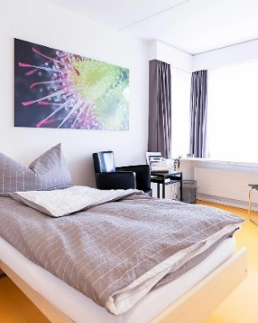 | 1 night / 2 nights  Single room CHF162.00 / CHF324.00  Dble room CHF145.00 / CHF290.00
Pilgerhaus | Simple rooms.  1-4 beds, shared WC/shower,  no elevator | 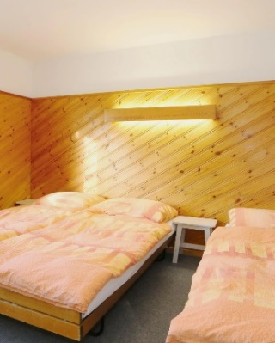 | Single room CHF125.00 / CHF250.00  Dble room CHF118.00 / CHF236.00  3-bed room CHF111.00 / CHF222.00  4-bed room CHF108.00 / CHF216.00
Gruppenhaus | Budget option  2-6 bed bunks  Bring a sleeping bag & towel for no extra cost | 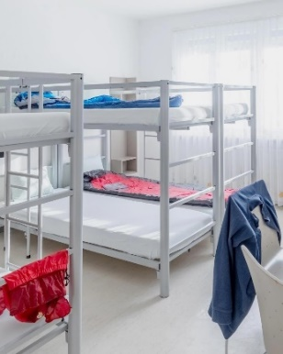 | Adults: CHF85.00 / CHF170.00  12-14: CHF68.00 / CHF136.00  6-11: CHF42.00 / CHF 84.00  plus CHF15 per duvet if you do not bring your own
Day guests |  |  | CHF10.00 per day + meals  Adults: CHF30.00 per meal  Kids 6-14: CHF15.00 per meal
The overnight prices include all meals, a retreat fee of CHF10 per person per day (Sat & Sun) to cover the rented communal rooms and a tourist tax of CHF2.60 per person per night.

If you would like financial assistance the corresponding box in the sign-up form and Birgit or the church office will get back to you. We will find an individual solution.

General information:
The retreat is from May 12 - 14 (Friday evening to Sunday noon). 1-night bookings possible.
Room categories and attendance are limited. In general, reservations are done on a first-come, first-served basis. Overnight guests will be given priority over day guests.
- Meals will be provided from Friday dinner to Sunday lunch.
- For more information about the hotel, see hotel-allegro.ch.
For any questions, please contact Birgit at retreats@ipc-zurich.org, the church office at office@ipc-zurich.org, or come to our sign-up tables on Sunday.
Costs calculation for 2023 Retreat

Name:

 | Fri night cost | Sat night cost | Bedding  CHF15 | TOTAL
Adults

Youth
12-14

Kids
6-11

Kids
0-5
(free)
 | CHF10 per day | Adult per meal | Kids 6-14  per meal
Day guest |  | CHF30.00 | CHF15.00
FINAL TOTAL

