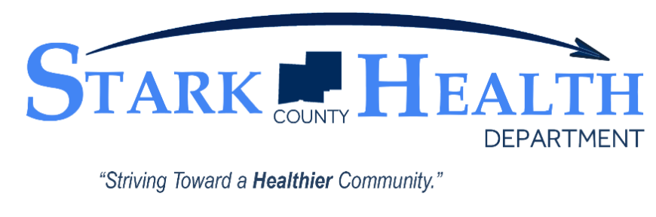
Contact: Kay Conley
330.451.1446
conleyk@starkhealth.org

November 16, 2020
For Immediate Release
NEWS

Stark County Health Department issues statement on
test results and changes to case and contact protocols

(Jackson Twp., OH) – The Stark County Health Department has issued a statement regarding what individuals should do who have received a test for COVID-19 and are awaiting their results. The message to those individuals is simple, stay home until you know. The goal is to remind those awaiting results to being isolating in their residence until they know the results of their test.
“It is important for those who get tested to remember that they should be in isolation at home until they know for sure that they are negative with no symptoms before leaving their place of residence,” said Kirkland Norris, RS, MPH, Health Commissioner of the Stark County Health Department. “If an individual does test positive, they should continue with isolation for a minimum of 10-days and anyone that is a close contact (inside or outside of the home) should begin their quarantine for 14-days.”
Individuals that have been identified as a contact should continue with their quarantine for their respective timeframe. Testing negative does not remove a contact from quarantine before the specified timeframe.
This campaign from the Stark County Health Department is hoping to clear up any confusion that individuals should NOT continue their regular schedule (i.e. school, work, shopping, etc.) while awaiting results. A positive case, not knowing, could continue to spread the virus to others. That is why it is important to, “Stay Home Until You Know” in order to not infect others around you.
“We understand that this can be a frustrating process and a waiting game until the facility calls you back but it is important to curb community spread of the virus,” said Norris.
The statement also makes mention of the changes to protocols for handling cases and contacts. Due to the rapid increase in the number of new cases the Stark County Health Department is receiving, there may be situations where health department staff or contact tracers cannot reach out to them in a timely fashion. Or cases may only receive a phone message or letter with information.
“We want to thank everyone for their cooperation during this time. It is most certainly frustrating for everyone who may not get a call back right away from our department. I assure you that we are moving as fast as we can to reach out to cases and contacts in a timely fashion,” said Norris. “I would ask that you monitor your state of health and take the proper actions asked of you. That means isolating if a case or quarantining if a contact.” Individuals should also reach out to their primary care physician or community health clinic if symptoms persist or if they have health concerns.
It is imperative that everyone increase their efforts to slow the spread of COVID-19 in the community. Now is the time to focus on the measures we know can slow the spread of the virus and protect yourself and others:
- Stay home if you are sick
- Stay home if you have been exposed to COVID-19
- Avoid gatherings and reconsider holiday plans
- Limit contact with people outside of your household
- Keep six (6) feet of distance from others
- Wear a mask or facial covering
- Wash your hands frequently for at least 20 seconds
The Stark County Combined General Health District (Stark County Health Department) was founded in 1920 and is celebrating a century of health. The department is currently the ninth largest health district in the State of Ohio which serves the public health needs of over 250,000 people. The jurisdiction of the Stark County District is that of the 17 Townships, 12 Villages, and the cities of Louisville, North Canton, and Canal Fulton. The mission of the department is to assess, protect, promote, and improve the health of Stark County through leadership, quality service, and community partnerships.

###

