Get Ready! – Jesus Storybook Bible

Opening Discussion Question: What is your favorite story about God/Jesus?

Watch, read, or listen to the story ‘Get Ready!’ using this link:
https://www.youtube.com/watch?v=q5uH-v9OUy0

Scripture: Nehemiah 8-10, Malachi 1, 3, and 4, Ezra 7

Pre-K Questions:
- Why do we have rules? What are some rules in your house?
- Do we always follow those rules perfectly?
- How did the people feel after reading all of God’s rules?
- Does God allow us to have fun? And be happy?
- God doesn’t want to punish us; he wants to rescue us…how does he do that?

Elementary Questions:
- How did the people respond after going over God’s rules?
- What does Nehemiah’s name mean?
- Is it possible to follow every single command from God?
- Does God still love us even though we disobey? Is that easy or hard to understand?
- Why was God going to send His Son? And how does that help the people in the story with all their rules?

Conclusion:
When the people heard God’s rules, they realized they could not keep them; that is why they were so sad and afraid. But then they remembered that it is not the rules that save them, but God that saves them. They remembered that God had told them that the Rescuer is coming.

Activities

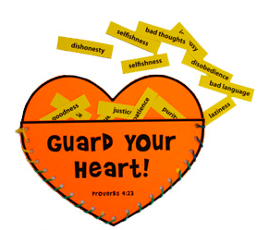

Pray as a family.

