God’s Messenger- Jesus Storybook Bible

Opening Discussion Question: Describe the worst storm you have ever seen? Was it scary?

Watch, read, or listen to the story about God’s Messenger using this link:
https://www.youtube.com/watch?v=ytd74b7U2TE

Scripture: Jonah 1-4; Hebrews 1:1-2

Pre-K Questions:
- Did Jonah listen to God?
- Where did Jonah go?
- Why was there a big storm while Jonah was out at sea?
- Where did Jonah live for 3 days? Do you think that was stinky?
- Did Jonah end up listening to God?
- Did God ever stop loving Jonah, even though he disobeyed?

Elementary Questions:
- Where did God tell Jonah to go and what did he want Jonah to do?
- What was Jonah’s plan? Why was that a foolish plan?
- How did Jonah know that God wasn’t happy with him?
- How long did Jonah stay inside the big fish?
- Jonah ran away from God and we learned that that doesn’t work, so how do we run towards God?
- How does this story represent Jesus?

Activities

Coloring: https://i.pinimg.com/originals/03/bc/34/03bc34b243965bc40571d69fef0d1536.jpg

Craft:
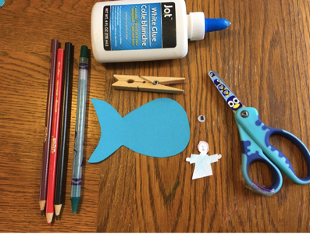

Pray as a family.

