He’s here! - Jesus Storybook Bible

Opening Discussion Question: We are entering into the New Testament, what is the difference between the Old Testament and New Testament? Who really plays a huge role in the New Testament?

Watch, read, or listen to the story ‘He’s here!’ using this link: https://www.youtube.com/watch?v=E2y2FJqsv_8

Scripture: Luke 1-2

Pre-K Questions:
- Why was God waiting for this moment? For His son to be born on earth?
- Who was the woman the angel talked to?
- What did the angel say?
- Why is this baby so important?
- Where was he born?
- Did you learn anything new about Jesus today?

Elementary Questions:
- Why was God waiting for this moment? Why is it so exciting for Him?
- How did Mary respond to the angel’s news?
- What does Jesus name mean?
- Why did Jesus come to earth quietly and “not flashy”?
- What does the story tell us about God’s character?

Activity:
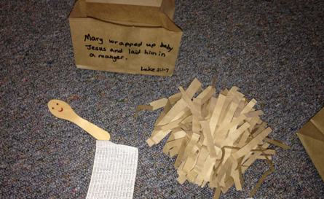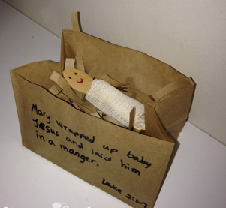

Pray as a family.

