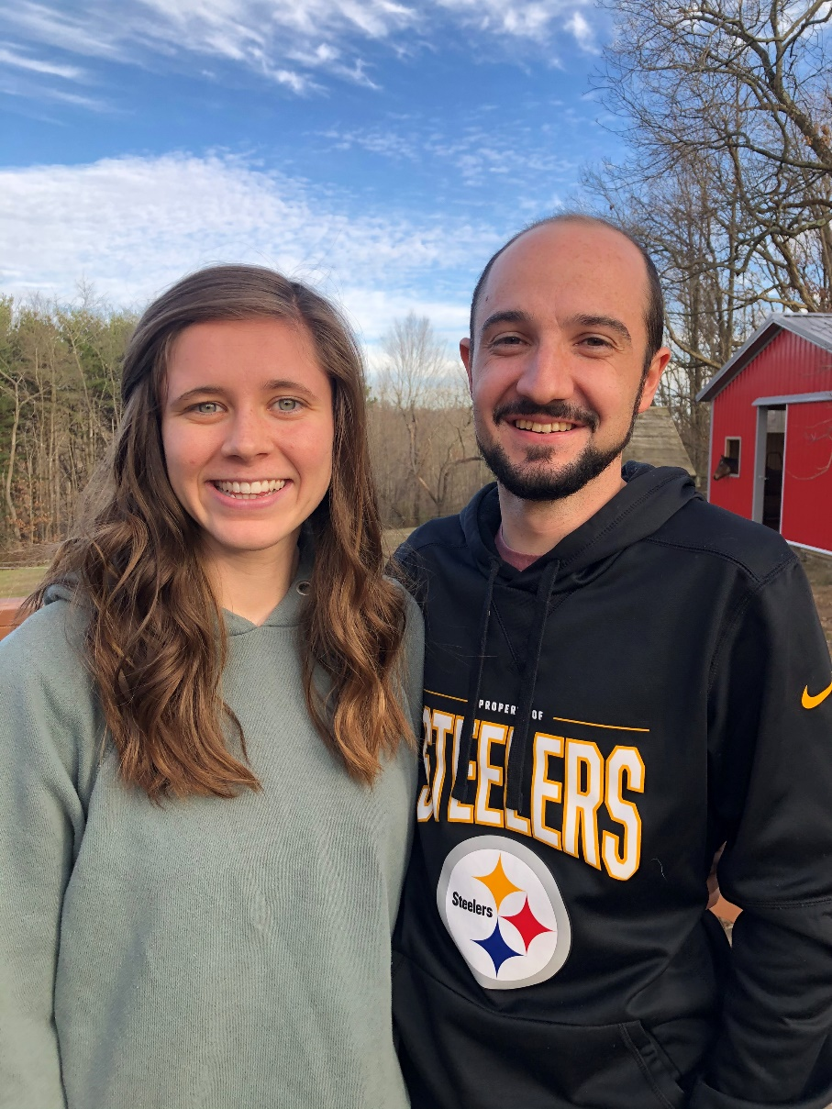
Evan and Holly Shaw moved to the Yakama Reservation in 2019. They plan to move and live full-time on the Warm Springs Reservation (Oregon) after living on the Yakama Reservation. They lead and coordinate the short-term teams in Warm Springs.
The Shaws have been starting up a school assistance program in Yakama once again. Please be in prayer for the kids and youth who have been and will be participating. Pray especially for two youth who were shot just before Christmas; that they will recover completely and are able to return soon to learn more of God's grace and peace.
Evan and Holly were able to have a small Christmas party for kids in Warm Springs, despite COVID restrictions. They are hoping to be able to return for Valentine's Day as well. Pray that it will become safe for the tribe to reopen things so that the Shaw's are able to be more involved in Warm Springs; to have more opportunities to share God's love with the people there. The need is great.
The Shaw's expressed appreciation and love for the people of Oak Hills. The Christmas cards we sent were great fun to read and a source of real encouragement. They are thankful for our continued prayers and financial support in order to further God's kingdom here on earth.
"Let us run with endurance the race that is set before us, looking to Jesus, the founder and perfecter of our faith, who for the joy that was set before him endured the cross, despising the shame, and is seated at the right hand of the throne of God." Hebrews 12:1-2

