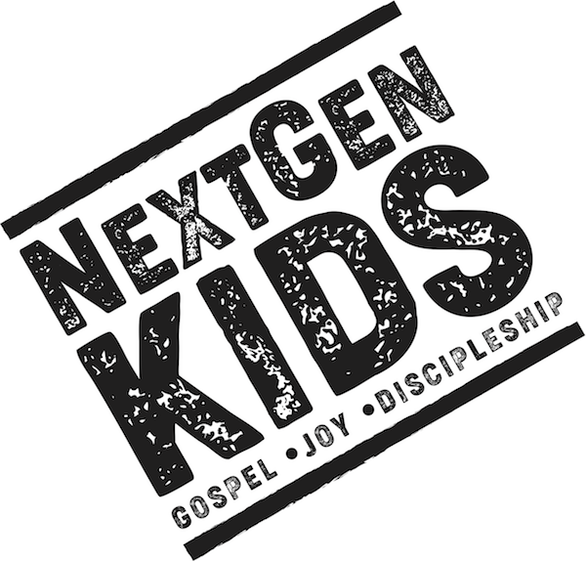

Spring 2020
Unit 10: Samuel and King Saul

Big Picture Question: Is anything or anyone greater than God?
No, God is greater than everything and everyone.

January 14: Hannah and Samuel (1 Samuel 1-3)
Jeremiah 10:6 There is none like you, O LORD; you are great, and your name is great in might.

January 21: The Ark was Captured (1 Samuel 4-6)
Psalm 73:28 But for me it is good to be near God; I have made the Lord God my refuge, that I may tell of all your works.

January 28: Israel’s First King (1 Samuel 8-15)
Psalm 145:1-2 I will extol you, my God and King, and bless your name forever and ever. 2 Every day I will bless you and praise your name forever and ever.

Unit 11: David was Anointed
Big Picture Question: How is Jesus the Perfect King? Jesus perfectly rules over the universe as the King of kings.

February 4: David was Anointed (1 Samuel 16-17)
Psalm 145:13 Your kingdom is an everlasting kingdom, and your dominion endures throughout all generations.

February 11: David Showed Mercy (1 Samuel 24)
Psalm 23:1-2 The Lord is my Shepherd; I shall not want. 2He makes me lie down in green pastures. He leads me beside still waters.

February 18: God’s Covenant with David (2 Samuel 6-7)
Psalm 23:3 He restores my soul. He leads me in paths of righteousness for his name’s sake.

February 25: David’s Kindness (2 Samuel 9)
Psalm 23:4 Even though I walk through the valley of the shadow of death, I will fear no evil for you are with me; your rod and your staff they comfort me.

March 3: David Sinned and Was Restored (2 Samuel 11-12; Psalm 51)
Psalm 23:5 You prepare a table before me in the presence of my enemies; you anoint my head with oil; my cup overflows.

March 10: David’s Psalm (Psalm 23)
Psalm 23:6 Surely goodness and mercy shall follow me all the days of my life, and I shall dwell in the house of the Lord forever.
Unit 12: Wise King Solomon
Big Picture Question: What does God know? God knows everything about the past, present and future.

March 17: Solomon asked for Wisdom (1 Kings 2-3)
James 1:5 If any of you lacks wisdom, let him ask God, who gives generously to all without reproach and it will be given to him.

March 24: Wisdom for God’s People (Proverbs; Ecclesiastes; Song of Songs)
Memory Master Recitation

March 31: Solomon Built the Temple (1 Kings 6-8)
Awards during the Opening

