Dismantling Sentimental Christianity and Secular Fools
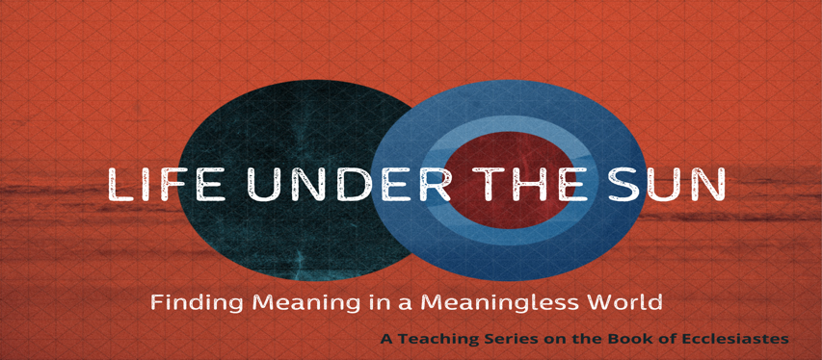

Ecclesiastes 1:1–2

How would you describe the book of Ecclesiastes? ___________________________________
_____________________________________________________________________________

- Ecclesiastes is part of the biblical genre known as ____________________________.
- Wisdom literature—provide the skills necessary to navigate life successfully.

Two Major Themes:
- Dismantle sentimental religion.
- Demonstrate the absurdity of life apart from God.

- DISMANTLE SENTIMENTAL RELIGION.

- Authorship.
- Who is Qoheleth? Qahal (assembly)—teacher, preacher, leader of assembly.
- Solomon? Probably a later author using Solomon as a cautionary tale.

- Context.
- Written during a time of religious decline (postexilic).
- Written during a time of economic expansion and opportunity (Ptolemies? 3rd century BC).
- Written to aristocracy who were pursuing pleasure in materialism.

- Purpose.
- Bring back into balance a theology that had gotten off track (i.e., Proverbs).
- The Jews had oversimplified the complexities of life.
- Illustration: C.S. Lewis in A Grief Observed.
- What are some aspects/presuppositions of sentimental Christianity? ___________
____________________________________________________________________________________________________________________________________

- DEMONSTRATE THE ABSURDITY OF LIFE APART FROM GOD.

- Vanity of Vanities.
- Hebel (35x)—mist, vapor, smoke. Trans. meaningless, futility, mystery.
- Absurdity of life apart from God.

- Under the Sun (30x).
- That which pertains to this age (secularism).
- What are some of the pursuits that belong to life under the sun? ______________
__________________________________________________________________
- What better cautionary tale could be told than the example of Solomon?

- Apologetic Method of the Preacher.
- Employs secular culture as his starting point and systematically dismantles their ideologies.
- Illustration of Paul on Mars Hill (Acts 17). How does Paul approach proclaiming the gospel in a secular culture? ________________________________________
__________________________________________________________________

- What Is the Conclusion of the Matter?
- Fear God and keep his commandments, for this is the whole duty of man (12:13–14).
- Where is Christ in Ecclesiastes?
- ____________________________________________________________
- ____________________________________________________________
- ____________________________________________________________
- ____________________________________________________________
- ____________________________________________________________
- ____________________________________________________________
- ____________________________________________________________

