What is the Meaning of Life?
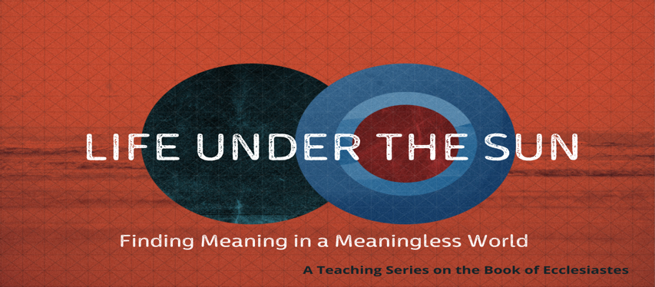

Ecclesiastes 1:12–2:11

“He who has a ‘why’ to live for can bear with almost any ‘how.’” Nietzche

“It is the very pursuit of happiness that thwarts happiness. The more one makes happiness an aim, the more he misses the aim.” Victor Frankl

The Preacher seeks to demonstrate that life is meaningless apart from God by marshaling two witnesses to the stand: human philosophy and hedonism.

- THE FUTILITY OF HUMAN PHILOSOPHY.

- The Pursuit of Wisdom (vv. 12–15).
- The Preacher gave himself fully to the pursuit of wisdom. Note “under the sun.”
- The pursuit of human wisdom leads to dissatisfaction.
- It is striving after the wind.
- Human wisdom cannot change the fixed order of the universe.

- The Pursuit of Morality (vv. 16–18).
- What is the meaning of morality?
- Worldly wisdom leads to frustration.

- THE FUTILITY OF HEDONISM.

- The Test of Pleasure (vv. 1–8).
- Note the number of “I’s.” Implying self-indulgence.
- Frivolity (v. 2).
- Wine (v. 3).
- Industry (vv. 4–6).
- Wealth (v. 7).
- Sex (v. 8).

- The Reward of Pleasure.
- Ultimately it is all meaningless.
“If I find in myself a desire which no experience in this world can satisfy, the most probable explanation is that I was made for another world.” C. S. Lewis

