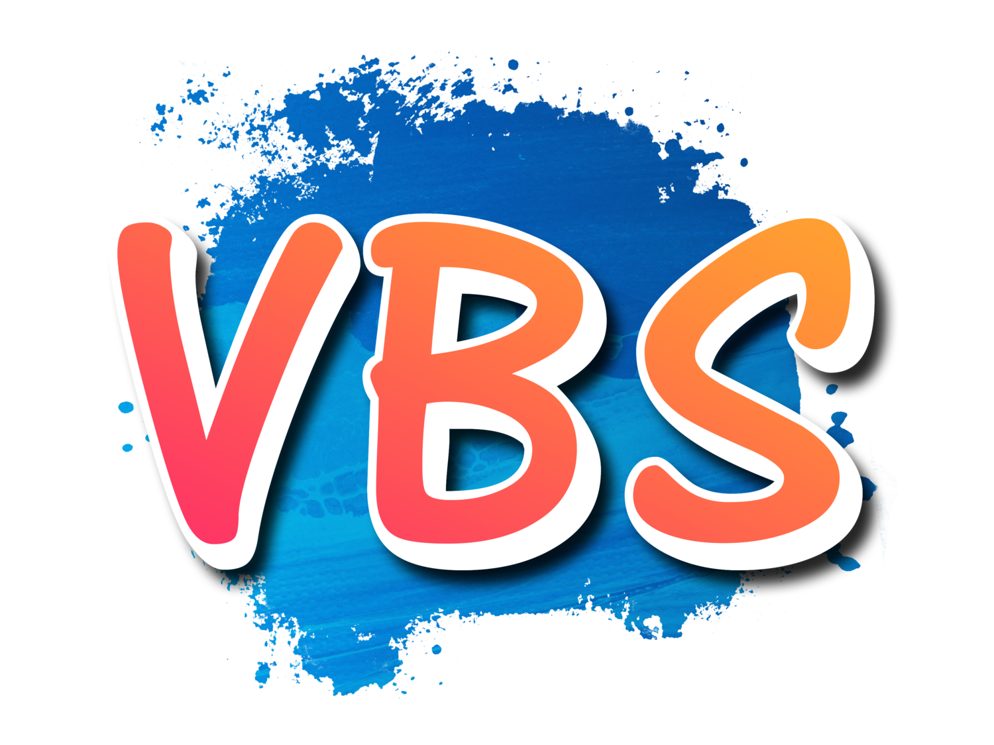 | God is Leading Us each day in Every Way!  VBS Registration Form  One Form Per Family
Form can be emailed directly to: Cindyp@stp2.org with VBS 2021 in the Subject Line
Name(s)
Age(s) & gender: _______________________________________ ________________________

_______________________________________ ________________________

_______________________________________ ________________________

_______________________________________ ________________________

Parent’s Names: ________________________________________________________________

Street Address: _________________________________________________________________

City: _________________________________, State: _______________, Zip:________________

Home Phone #: ______________________________ Cell #:_____________________________

Home email address:_____________________________________________________________

Who will be picking up child(ren): __________________________________________________

In case of Emergency, contact: _____________________________________________________
Name and phone number

Allergies or other medical conditions: _______________________________________________

______________________________________________________________________________

Home Church: __________________________________________________________________

Name of special friend your child might like to be with: _________________________________

Small Group Name (for church use only): ____________________________________________

