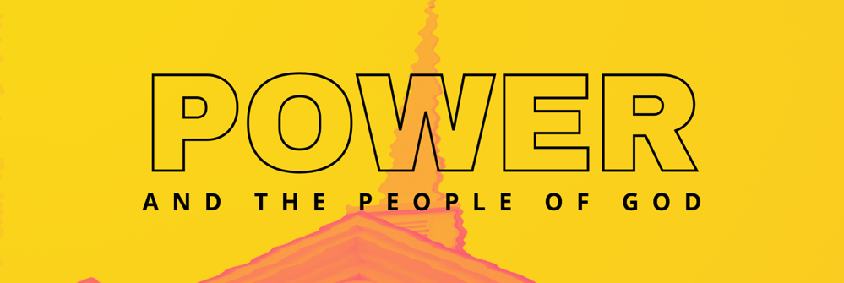
Hidden Powers
November 14, 2021

HOME GROUP QUESTIONS

- Have one or two people read aloud Ephesians 6:10-20.
- We very rarely hear about “hidden powers” in our cultural discourse. Why do you think this is? In your life in the church, how often has this topic been addressed?
- What point do you think Paul was making when he said “we do not wrestle against flesh and blood, but against the rulers, against the authorities, etc.?”
- Rob said, “The work of these evil hidden powers is not just individualistic. It can also be systemic.” Do you agree? Why or why not? Can you think of some examples? (See Galatians 4:8-9; 1 Corinthians 10:19-22)
- Rob asked if we are becoming “functional materialists.” In other words, we believe in spiritual beings, but we live as if they don’t exist. In theory, we are theists, but functionally (our everyday lives) we are materialists. To what degree is this true of you?
- What does it mean that our enemy is DEFEATED but not DESTROYED?
- How has Jesus disarmed the principalities and powers of darkness (see Colossians 2:13-15)? How should this affect how we stand against the evil one?
- Our strategy to stand against the forces of darkness is to put on the full armour of God, which is to put on Christ. Our position in Christ and all that he provides for us will enable us to stand. But sometimes we try to stand in world power or our own power. What could happen if we become co-conspirators with the world in its pursuit of power?

ADDITIONAL RESOURCES
THE A-LIST
Tim Keller’s Article: A Biblical Critique of Secular Justice and Critical Theory
If you are looking for a good overview of Social Justice Theory, complete with a thorough biblical critique, this is the place to go. A thoughtful and disciplined summary. Click here for a link.
Playing God by Andy Crouch
Learn about how power can make human flourishing possible or about how it can destroy the image of God in people. This is a fantastic place to start, a strong recommend.
The Coddling of the American Mind by Greg Lukianoff and Jonathan Haidt
Rob recommends this book everywhere he goes. He has his whole family reading it. He believes every parent needs to read it. It’s a book that explores what has gone wrong on college campuses in the past decade – why there is rising intolerance for opposing viewpoints and why students and professors are afraid to speak up. It also tackles topics like rising depression, political polarization, and cancel culture. Well researched, thoughtful, and illuminating. It’s not a faith-based book, but don’t let that stop you.
Cynical Theories by Helen Pluckrose and James Lindsay
This book is a brilliant critique of Critical Theory. It is thorough and in-depth. It is not written from a faith perspective, but from two authors who are classic liberal thinkers. Still, their concerns and arguments against Critical Theory are valid, reasonable, and accessible to someone looking at it from a faith perspective. This book gets mentioned a lot by a lot of people. It’s the “go to” book for this subject.

THE ALMOST A-LIST
The Way of the Dragon or the Way of the Lamb by Jamin Goggin and Kyle Strobel
This book explores the biblical understanding of power, especially the Bible’s vision of power in weakness. It examines how God’s power is antithetical to the power of the world and includes interviews with prominent Christian thinkers.
A Church Called Tov by Scott McNight and Laura Barringer
This book looks at what it takes to form a culture of goodness in our churches that will resist abuses of power, promote healing, and eradicate the toxic fallout that can infect Christian organizations.
A Theology of Power: Being Beyond Domination by Kyle A. Pasewark
This is a DEEP philosophical dive that explores Foucault, Luther, and Tillich. If you really want to get lost in the nuances of postmodernism and theology….

