Got Questions? There’s Q&A after the message: 587-415-1554

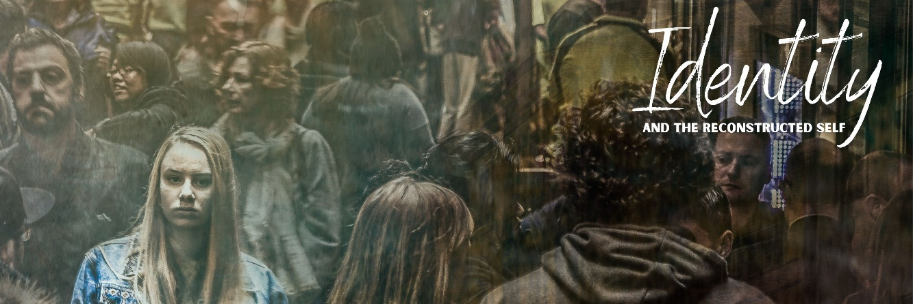
The COMPLETE SELF
November 8, 2020

Our understanding of personal identity
has never been more fragmented.

Michael Jackson
Fixed Points of Reference

Vertical Self - your vision of yourself as part of a greater transcendent spiritual reality.

Horizontal Self – your vision of yourself that is part of the physical, imminent world around you and inner person.

Expressive Individualism – the way to reach the highest good is through self-definition and self-expression

Why do punk rockers look the same?

The Curated Self:

The Compartmentalized Self:

Matthew 23:1-3, 25-28
Then Jesus said to the crowds and to his disciples, ² “The scribes and the Pharisees sit on Moses’ seat, ³ so do and observe whatever they tell you, but not the works they do. For they preach, but do not practice.
²⁵ “Woe to you, scribes and Pharisees, hypocrites! For you clean the outside of the cup and the plate, but inside they are full of greed and self-indulgence. ²⁶ You blind Pharisee! First clean the inside of the cup and the plate, that the outside also may be clean.
²⁷ “Woe to you, scribes and Pharisees, hypocrites! For you are like whitewashed tombs, which outwardly appear beautiful, but within are full of dead people’s bones and all uncleanness. ²⁸ So you also outwardly appear righteous to others, but within you are full of hypocrisy and lawlessness.

Jesus provides a .

Jesus supports .

Jesus invites .

John 3:19-20 and John 8:12

James 5:16 and Ephesians 4:25

Are you willing to trust Jesus and others with yourself?

Reflection Questions

So just how fragmented is your identity? How much congruence would you say you still need between your public and private identity (very little, some, a lot)?

How do you see curation and compartmentalization at work in your life?

What do you think about the statement “true Christ-centred gospel community means trusting others with myself?”

Recommended Reads

Practical and Theoretical!
Sayers, Mark. The Vertical Self. Thomas Nelson, 2010.

Thrall, Bill, McNicol, Bruce, and Lynch, John. True Faced: Trust God and Others with Who You Really Are, 2004

More theoretical!
Trueman, Carl R. The Rise and Triumph of the Modern Self. Crossway, 2020.

Smith, James K.A. Who’s Afraid of Postmodernism? Baker Academic, 2006.

Uber theoretical!
Smith, James K.A. How (Not) to Be Secular: Reading Charles Taylor. Wm. B. Eerdmans Publishing Co., 2014.

