Got Questions? There’s Q&A after the message: 587-415-1554

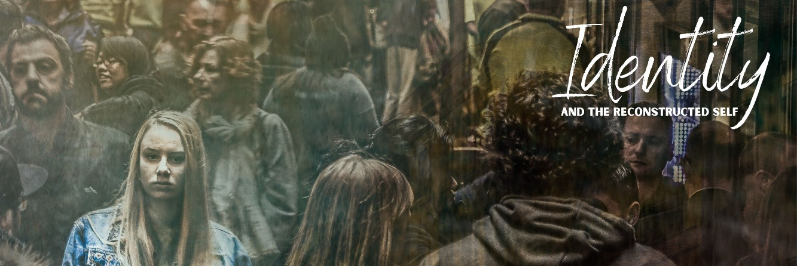
The LIBERATED SELF
November 15, 2020

The Post-Truth Landscape

SOFT Post-Truth:
I acknowledge that truth exists (or certain things are true) but I don’t care about the truth if it gets in the way of our personal preferences

HARD Post-Truth:
I’m willing to propagate blatant falsehoods, even though knowing they’re false, because doing so serves a higher political or social agenda

Example: Joshua Feuerstein

How did we get here?

We misunderstand the place of freedom in respect to truth.

Our understanding of freedom is limited.

Autonomy
autos = “self” nomos = “law”
literally, “a law unto myself”

Our understanding of freedom is one-sided.

Freedom FROM
Freedom FOR

How do we navigate this culture of confusion?

John 8:31-38
³¹ So Jesus said to the Jews who had believed him, “If you abide in my word, you are truly my disciples, ³² and you will know the truth, and the truth will set you free.” ³³ They answered him, “We are offspring of Abraham and have never been enslaved to anyone. How is it that you say, ‘You will become free’?”
³⁴ Jesus answered them, “Truly, truly, I say to you, everyone who practices sin is a slave to sin. ³⁵ The slave does not remain in the house forever; the son remains forever. ³⁶ So if the Son sets you free, you will be free indeed. ³⁷ I know that you are offspring of Abraham; yet you seek to kill me because my word finds no place in you. ³⁸ I speak of what I have seen with my Father, and you do what you have heard from your father.”

- Genuine faith liberates.

vv. 31-33
shallow faith = “the Jews who had believed him”

- Sin enslaves.

vv. 34-35
sin = “to miss the mark”
Romans 3:23; 1 John 1:10
Psalm 51:5

- The Son has authority to bring freedom.

vv. 36-38
John 3:35

The PENALTY and POWER of sin
Romans 6:6-7

Reflection Questions

How have you seen autonomy or soft post-truth at work in your life?

Have you ever felt discomfort in using the word “sin”? If so, why?

What freedom “for” do you think Jesus is inviting you to step into today?

Recommended Reads

Practical and Theoretical!
Sayers, Mark. The Vertical Self. Thomas Nelson, 2010.

Murray, Abdu. Saving Truth. Zondervan, 2018.

More theoretical!
Trueman, Carl R. The Rise and Triumph of the Modern Self. Crossway, 2020.

Smith, James K.A. Who’s Afraid of Postmodernism? Baker Academic, 2006.

Uber theoretical!
Smith, James K.A. How (Not) to Be Secular: Reading Charles Taylor. Wm. B. Eerdmans Publishing Co., 2014.

