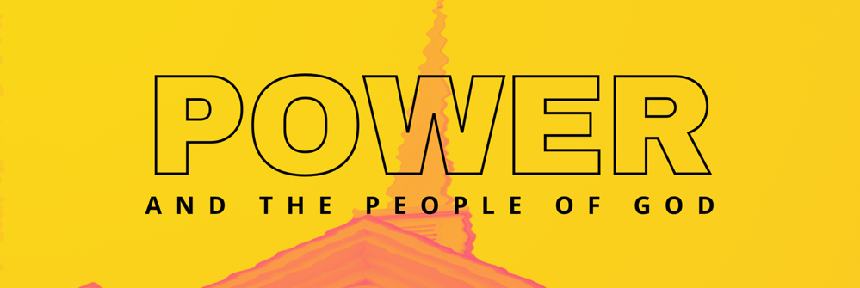
Weak Power
November 7, 2021

2 Corinthians 12:7-10 (NIV)
7 or because of these surpassingly great revelations. Therefore, in order to keep me from becoming conceited, I was given a thorn in my flesh, a messenger of Satan, to torment me. 8 Three times I pleaded with the Lord to take it away from me. 9 But he said to me, “My grace is sufficient for you, for my power is made perfect in weakness.” Therefore I will boast all the more gladly about my weaknesses, so that Christ’s power may rest on me. 10 That is why, for Christ’s sake, I delight in weaknesses, in insults, in hardships, in persecutions, in difficulties. For when I am weak, then I am strong.

See also 2 Corinthians 11:16-31

- Where does power really come from?

The Way of Weakness

“Living in full dependence upon God, moving forward to embrace every weakness so that God’s glory might be revealed.”

2 Misconceptions:

- Weakness is Self-Loathing
James 4:6

- Weakness is Rejecting God-given Strengths and Abilities
Revelation 22:1-2

Hubris Syndrome

- What does true flourishing look like?

1 Samuel 16:7

ADDITIONAL RESOURCES
THE A-LIST
Tim Keller’s Article: A Biblical Critique of Secular Justice and Critical Theory
If you are looking for a good overview of Social Justice Theory, complete with a thorough biblical critique, this is the place to go. A thoughtful and disciplined summary. Click here for a link.
Playing God by Andy Crouch
Learn about how power can make human flourishing possible or about how it can destroy the image of God in people. This is a fantastic place to start, a strong recommend.
The Coddling of the American Mind by Greg Lukianoff and Jonathan Haidt
Rob recommends this book everywhere he goes. He has his whole family reading it. He believes every parent needs to read it. It’s a book that explores what has gone wrong on college campuses in the past decade – why there is rising intolerance for opposing viewpoints and why students and professors are afraid to speak up. It also tackles topics like rising depression, political polarization, and cancel culture. Well researched, thoughtful, and illuminating. It’s not a faith-based book, but don’t let that stop you.
Cynical Theories by Helen Pluckrose and James Lindsay
This book is a brilliant critique of Critical Theory. It is thorough and in-depth. It is not written from a faith perspective, but from two authors who are classic liberal thinkers. Still, their concerns and arguments against Critical Theory are valid, reasonable, and accessible to someone looking at it from a faith perspective. This book gets mentioned a lot by a lot of people. It’s the “go to” book for this subject.

THE ALMOST A-LIST
The Way of the Dragon or the Way of the Lamb by Jamin Goggin and Kyle Strobel
This book explores the biblical understanding of power, especially the Bible’s vision of power in weakness. It examines how God’s power is antithetical to the power of the world and includes interviews with prominent Christian thinkers.
A Church Called Tov by Scott McNight and Laura Barringer
This book looks at what it takes to form a culture of goodness in our churches that will resist abuses of power, promote healing, and eradicate the toxic fallout that can infect Christian organizations.
A Theology of Power: Being Beyond Domination by Kyle A. Pasewark
This is a DEEP philosophical dive that explores Foucault, Luther, and Tillich. If you really want to get lost in the nuances of postmodernism and theology….

