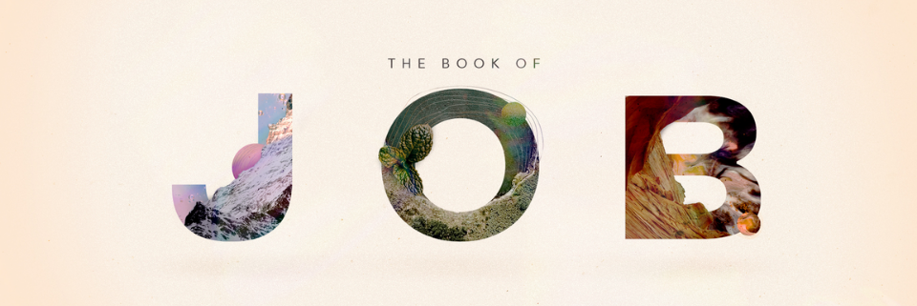
Four Responses to Suffering
The Story of Job
The Big Idea:
What we allow to shape our perspective (theology, people, circumstances) will impact our view of God when suffering happens.
Context and Background
The Retribution Principle:
“A common belief that the righteous will prosper and the wicked will suffer.”
Job’s Loss and Response
“At this, Job got up and tore his robe and shaved his head.” v20
Lament: [def: to express one's deep grief about]
“Watch what you reach for when you are in pain.” Aaron Stern

Job’s Wife’s Response
Job 2:9-10
Job’s Friends’ Response
Job 2:13
Job 3:1-5, 11-13, 24-26
Job 4 to Job 37
1. You can have good theology, but bad timing.
2. You can have good theology, but a bad spirit.
3. You can have good theology, but bad application of it.
JOB’S FRIENDS BAD THEOLOGY
1. All suffering is the result of someone’s sin (chapter 4)
2. If you just repent you won’t suffer (Ch 7:5-6)
3. You get what you deserve
4. The innocent don’t suffer
God’s grace is conditioned on his grace, not our merit.
God’s Response
Job 38: 1-13
1. God is wholly other.
2. God is the sustainer of the world.
3. Trust God’s wisdom and creative ways; even when you can’t figure it out.
Job’s Response to God
Job 42:1-6

