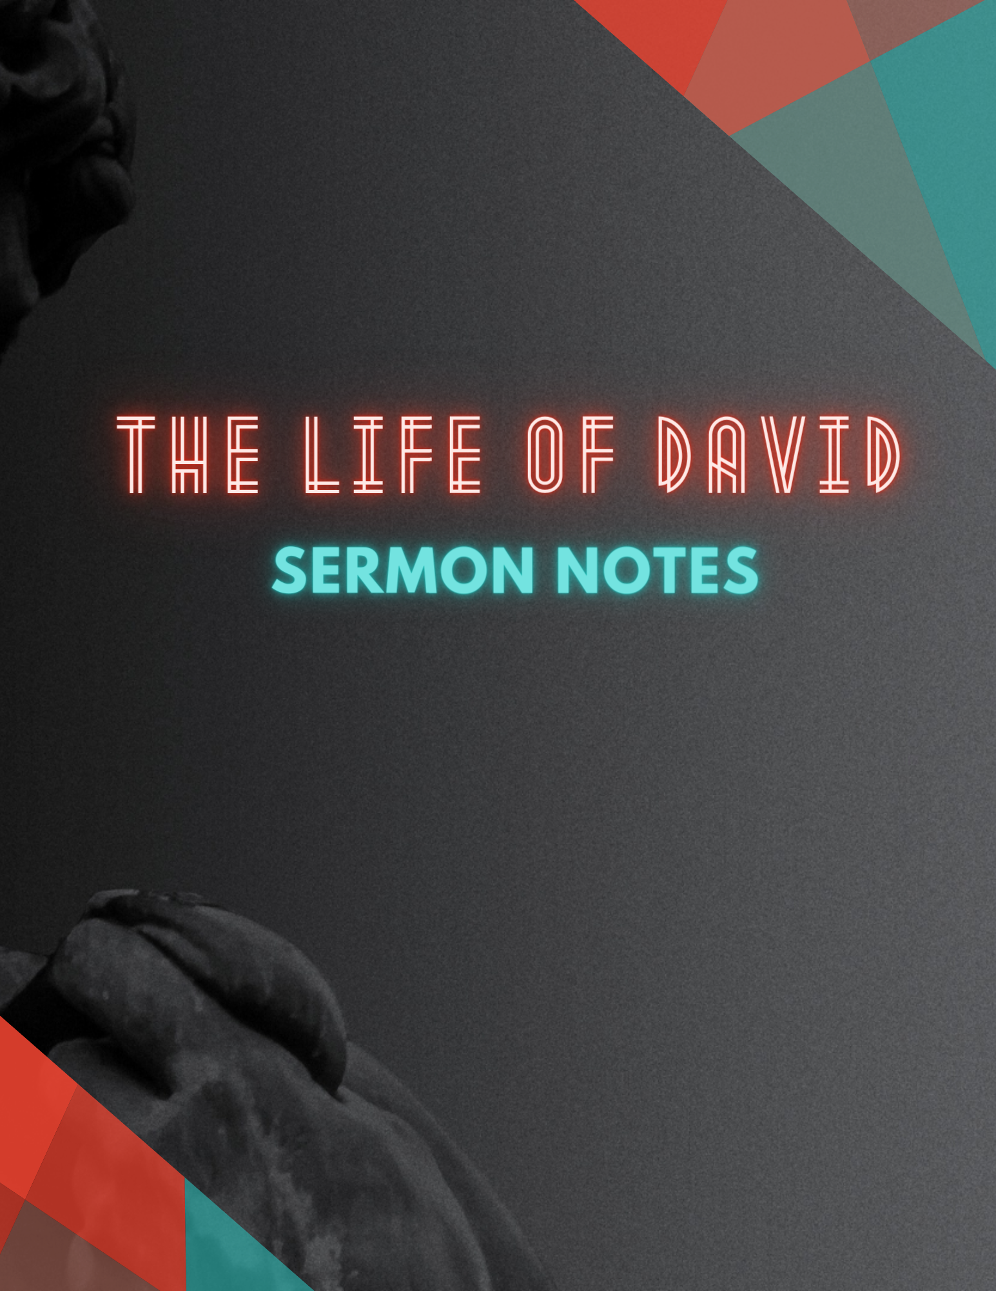
2 Samuel 18:10 ESV
And a certain man saw it and told Joab, “Behold, I saw Absalom hanging in an oak.”
________________________________________________________________________________
A Story in 8 Parts
2 Samuel 13 - 19

What can we learn from this story?

The power of sin.

The power of God.

