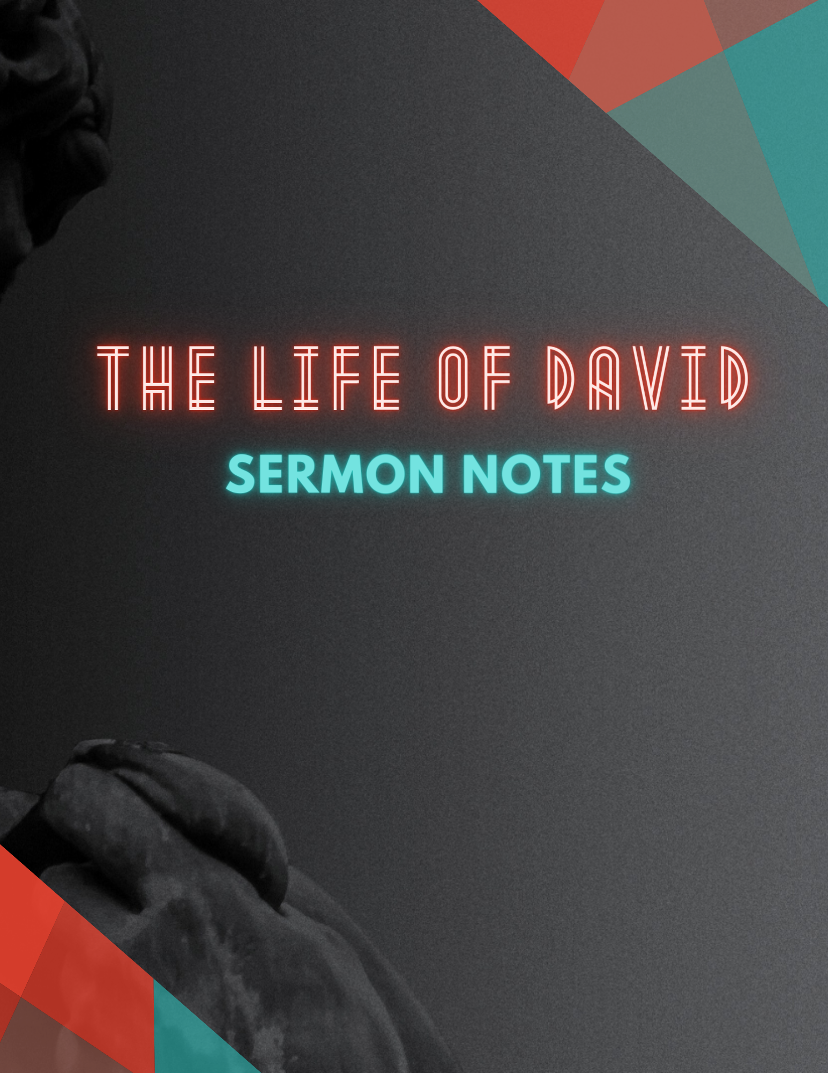
1 Samuel 17:32-40, 45-47 ESV
32 And David said to Saul, “Let no man's heart fail because of him. Your servant will go and fight with this Philistine.” 33 And Saul said to David, “You are not able to go against this Philistine to fight with him, for you are but a youth, and he has been a man of war from his youth.” 34 But David said to Saul, “Your servant used to keep sheep for his father. And when there came a lion, or a bear, and took a lamb from the flock, 35 I went after him and struck him and delivered it out of his mouth. And if he arose against me, I caught him by his beard and struck him and killed him. 36 Your servant has struck down both lions and bears, and this uncircumcised Philistine shall be like one of them, for he has defied the armies of the living God.” 37 And David said, “The Lord who delivered me from the paw of the lion and from the paw of the bear will deliver me from the hand of this Philistine.” And Saul said to David, “Go, and the Lord be with you!”
38 Then Saul clothed David with his armor. He put a helmet of bronze on his head and clothed him with a coat of mail, 39 and David strapped his sword over his armor. And he tried in vain to go, for he had not tested them. Then David said to Saul, “I cannot go with these, for I have not tested them.” So David put them off. 40 Then he took his staff in his hand and chose five smooth stones from the brook and put them in his shepherd's pouch. His sling was in his hand, and he approached the Philistine.
45 Then David said to the Philistine, “You come to me with a sword and with a spear and with a javelin, but I come to you in the name of the Lord of hosts, the God of the armies of Israel, whom you have defied. 46 This day the Lord will deliver you into my hand, and I will strike you down and cut off your head. And I will give the dead bodies of the host of the Philistines this day to the birds of the air and to the wild beasts of the earth, that all the earth may know that there is a God in Israel, 47 and that all this assembly may know that the Lord saves not with sword and spear. For the battle is the Lord's, and he will give you into our hand.”
________________________________________________________________________________
1 Samuel 17:34-37 – David trusts God to PREPARE him.
1 Samuel 17:38-39 – David trusts God to PROTECT him.
1 Samuel 17:40 – David trusts God to EQUIP him.
1 Samuel 17:45-47 – David trusts God to FIGHT FOR him.

GOD USES THOSE WHO TRUST IN HIM TO FULFILL HIS KINGDOM PLANS.

NOTES:

