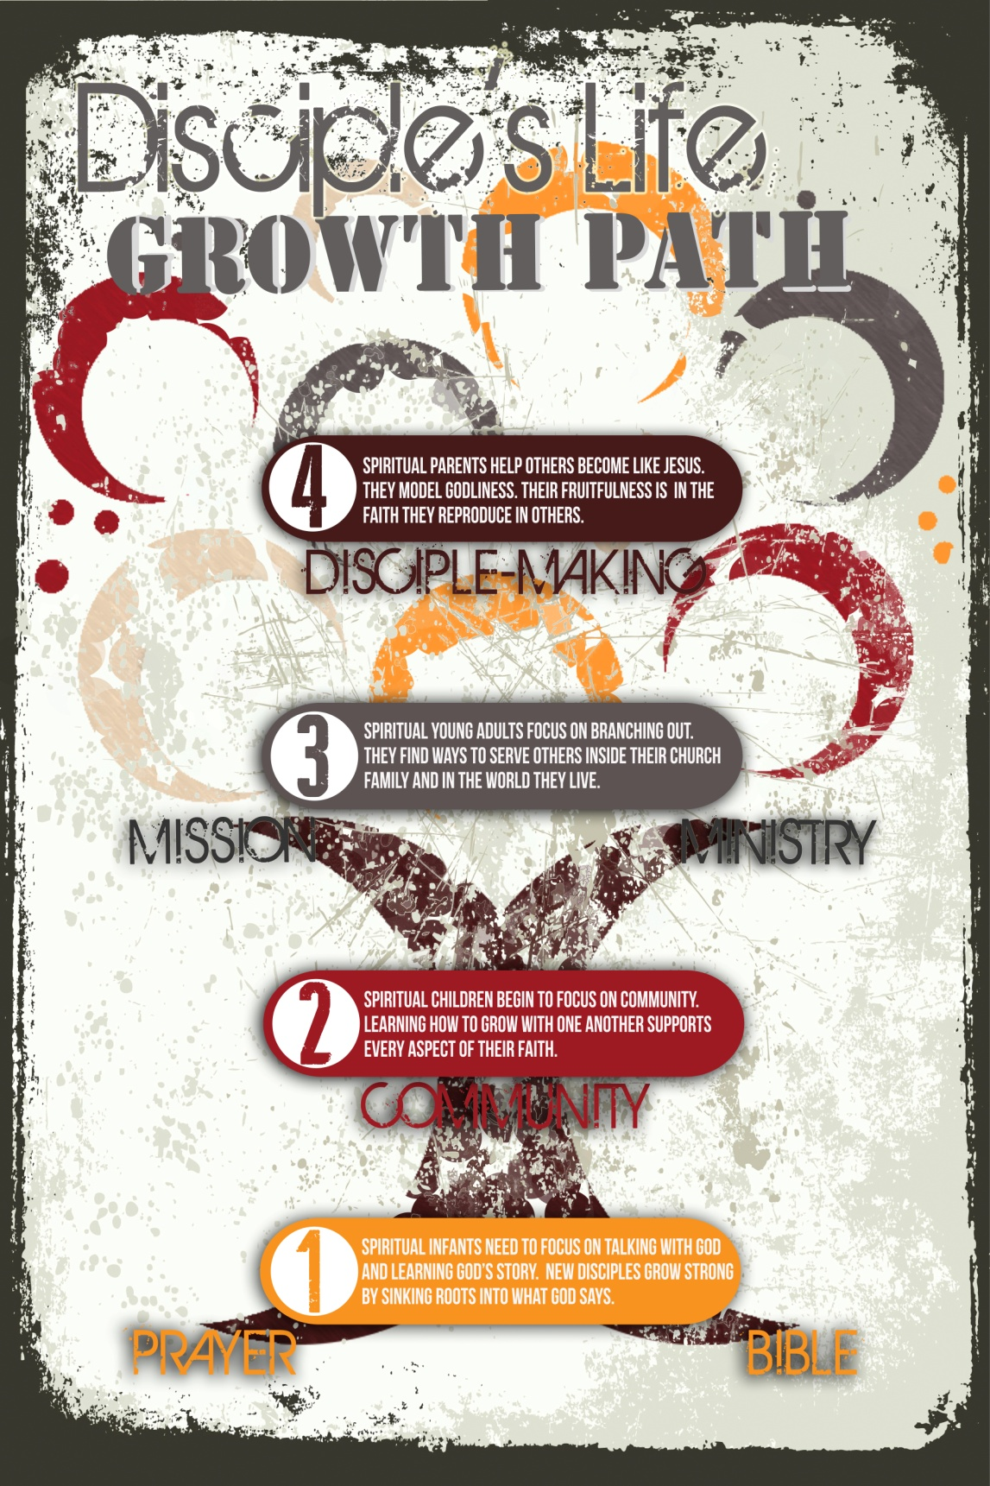
Disciple Life Path
Our dream at Zion Church is to create a culture where disciple-making is the means and measure of our effectiveness as a church family. Biblically, we are convinced that making disciples is God’s plan for every believer and for His church. We recognize the need to resource, train, and equip the Body to be effective in disciple-making. This takes time. Ultimately, disciple-making is best “caught,” rather than “taught.” Everyone needs someone they look to as their disciple-maker. If you aren’t looking to someone to help you intentionally grow as a disciple of Jesus, we encourage you to ask God to show you who He wants you to follow “as they follow Christ.”

Additionally, we encourage every disciple to begin praying about who God is calling you to disciple. One of our core values is “growing disciples grow disciples.” The best way to keep growing personally is to look outside of yourself and begin helping someone else grow as a disciple.

The following six lessons were adapted from the book and workbook “Real Life Discipleship” by Jim Putman. We are thankful for his Discipleship Wheel (see Appendix 1) that provides a simple visual of the stages of spiritual growth.

By the end of these lessons, our prayer is that you would…
- Know the definition of a disciple from Matthew 4:19.
- Understand the “stages” every disciple should experience on their journey with Jesus.
- Identify where you are personally on your journey as a disciple of Jesus.
- Learn the skills, habits, and practices vital to your continued growth as a disciple of Jesus.
- Commit to taking the necessary steps to move to the next “stage” in your journey.

Part 1- What is a disciple?

The Mission of the church is s e t t l e d.
Matthew 28:19-20

If we make disciples, Jesus will b u i l d His church.
Matthew 16:15-18

Too often, churches focus on b u i l d i n g their church,
rather than m a k i n g disciples. This is counter to what Jesus taught.

How do we make disciples?
“Go”- literally “as you are going”…the idea is that making
disciples is a l i f e s t y l e.

Who can we “go” to in our daily lives?
- Someone under our own roof
- Someone at work
- Someone we know through community involvement
- Someone in our neighborhood
- Someone in our family

Identify three people who are far from God and with whom you connect as you “go” about your daily life:
_________________________________________
_________________________________________
_________________________________________

“baptize”- this carries the idea of i d e n t i t y and
c o m m i t m e n t .

“teach them to obey”- teaching isn’t the goal; o b e d i e n c e is the goal.

T r a n s f o r m a t i o n, not transfer of information, is the byproduct of disciple-making.

What is a disciple?
The definition is in Jesus’ Invitation - Matthew 4:19

“Follow me” - A disciple is someone who is f o l l o w i n g
J e s u s.

They are living u n d e r H i s a u t h o r i t y. This is what it means to follow.
- John 12:26, Luke 9:22-24

What do you need to “leave behind” and “take up” in order to follow Jesus? Write down your thoughts.
________________________________________________
________________________________________________
________________________________________________

“I will make you” - A disciple is someone who is being
c h a n g e d b y J e s u s.
- Romans 8:29, Romans 12:1-2, Ephesians 3:16-19 (these all speak to ‘process’)

Acts 4:13 - It was clear these men had been changed by Jesus. How?

What are some ways we can spend time with Jesus so He can make us who He wants us to be?
_________________________________________________
_________________________________________________

“fishers of men” - A disciple is someone who is
c o m m i t t e d t o t h e m i s s i o n o f J e s u s.
- Luke 5:1-11, Luke 19:1-10

Making disciples is Jesus’ Plan A for reaching the world.
There is no P l a n B!

Zion must measure our “success” and “health” based on how
many people are actively involved in the process of b e i n g
a disciple and m a k i n g disciples.

The best way to learn how to make disciples is to learn how to be a disciple.

Review:
A disciple is someone who is f o l l o w i n g Jesus,
being c h a n g e d by Jesus and is committed to the
m i s s i o n of Jesus.

To make disciples, we must first be disciples.
Therefore, ask yourself…
- Am I someone who follows Jesus? How am I following Him?
- Is Jesus changing me? How is He changing me?
- What is the level of my commitment to the mission of Jesus? How am I looking for way to engage the mission of Jesus?

Part 2- The Spiritually Dead
Ephesians 2:1-5

Everyone is born s p i r i t u a l l y d e a d.
Ephesians 2:1

Spiritually dead people live o n l y f o r t h e m s e l v e s.
Ephesians 2:2-3

We can only be m a d e a l i v e through Jesus Christ.
Ephesians 2:4-5

What do the Spiritually Dead look like?

- U n b e l i e f

- R e b e l l i o n

Don’t be surprised when spiritually dead people act dead!

How can we identify someone in this stage?
The “Phrase from the Stage”

- “I believe there is a God. That’s good enough”
- “I go to church.”
- “God is just a crutch.”
- “There are many ways to get to God.”
- “There is no hell because God is a God of love.”
- “I have been a good person, so I will be okay.”
- “There is no absolute right or wrong.”

What do the spiritually dead need?

- A clear explanation of t h e g o s p e l
1 Peter 3:15
- To see the gospel l i v e d o u t - “proximity increases potency”

- Answers to their s p i r i t u a l q u e s t i o n s

- An invitation to f o l l o w J e s u s

How can you meet these needs for the people whose names you wrote in Part 1 who are “far from God” (spiritually dead)?
________________________________________________

When you are in a relationship with someone who is spiritually dead they need you to SHARE with them….

- Share your l i f e. - This was Jesus’ model.
Luke 5:27-32, Luke 7:36-50, Luke 11:37-42

- Share your p e r s o n a l t e s t i m o n y. Paul’s model from Acts 26 - before, how, after (see Appendix 2)

- Share the g o s p e l. (see Appendix 3)

In what ways can you SHARE with those you know to be “far from God” (spiritually dead)?
_________________________________________________

Take time to thank God for the person(s) who were instrumental in helping you move from “death” to “life.”

To make disciples, we must first be disciples.
Therefore, ask yourself…
- How am I sharing my life with people who are far from God?
- Can I clearly share with others how I became a follower of Jesus?
- Can I explain the gospel to someone enough to help them become a follower of Jesus?

Part 3- The Spiritual Infant
1 Peter 2:2-3

A spiritual infant k n o w s i t.
Colossians 1:13

A spiritual infant s h o w s i t.
1 Peter 2:1-2

What does a Spiritual Infant look like?

- I g n o r a n c e …concerning biblical truth

- C o n f u s i o n …about how to develop the habits of a disciple

- D e p e n d e n c e …on others for spiritual growth

This is not a BAD thing. It’s simply a reality at this stage.

How can we identify a Spiritual Infant?
The “Phrase from the Stage”

- “Why do I need to go to church regularly?”
- “I’ve been hurt by others, so it’s just me and God. I don’t need people.”
- “If I pray and read my Bible, will I be good enough to get to heaven?”
- “I provide for my family. I don’t have time for church.”
- “What should I do about my old friends who don’t believe?”
- “I am not sure I believe what the Bible says about that.”
- “I believe in Jesus, but is karma real too?”

What do Spiritual Infants need?
1 Thessalonians 2:6-8
- P e r s o n a l a t t e n t i o n from a disciple-making parent

- C a r e and p r o t e c t i o n

- T e a c h i n g and m o d e l i n g new truth

- To develop n e w h a b i t s that become rhythms they learn to live by

What spiritual habits do a spiritual infant need?

- B i b l e R e a d i n g

- P r a y e r

When you are in a relationship with someone who is a spiritual infant they need you to SHARE with them….

- Share your l i f e … regular time is critical

- Share new t r u t h …use good discipleship resources

- Share new h a b i t s …teach habits through modeling (Bible reading, prayer, sharing the gospel, church involvement)

In what ways are you currently SHARING with a spiritual infant?
________________________________________________
________________________________________________

To make disciples, we must first be disciples.
Therefore, ask yourself…
- How am I being changed by Jesus through His word?
- How am I growing in my intimacy and dependence on Jesus through prayer?
- Who am I helping to grow in this stage as a disciple?

Part 4- The Spiritual Child
1 Thessalonians 2:10-12

A spiritual child needs a m o d e l t o f o l l o w.
1 Thessalonians 2:10-11

A spiritual child needs to be s u p p o r t e d.
1 Thessalonians 2:12

A spiritual child needs to be s t r e t c h e d.
1 Thessalonians 2:12

What does a Spiritual Child look like?

- S e l f C e n t e r e d n e s s - faith is still viewed through a “me” filter

- I d e a l i s m - everything is black and white

- O v e r c o n f i d e n c e - shows itself as pride

- U n d e r - c o n f i d e n c e - shows itself as defeat

How can we identify a Spiritual Child?

The “Phrase from the Stage”

- “I believe in Jesus and my church is in the woods, just Him and me.”
- “Don’t break up my Life Group. It is comfortable for me right now.”
- “Who are all these new people coming to church? It’s getting too big.”
- “My Life Group is not taking care of me the way that they should.”
- “Nobody in the church is reaching out to me. No one is discipling me.”
- “I didn’t like the music today.”

What do Spiritual Children need?

- Connection to a c h u r c h f a m i l y

- Help to start f e e d i n g t h e m s e l v e s spiritually

- Teaching about w h o t h e y a r e in Christ

- Teaching about how to have authentic relationships

with o t h e r b e l i e v e r s

What spiritual habit does a Spiritual Child need?

- C o m m u n i t y - Acts 2:42-47

When you are in a relationship with someone who is a spiritual child they need you to CONNECT them with…

- G o d - 1 Corinthians 3:6-9

- C o m m u n i t y - Hebrews 3:12-13, Hebrews 10:24-25, “one anothers”

- P u r p o s e - Ephesians 4:12-13, 2 Corinthians 4:16-21

How can you help the spiritual children around you grow?
________________________________________________

To make disciples, we must first be disciples.
Therefore, ask yourself…
- How am I engaging in community as a disciple of Jesus?
- How can I take steps toward becoming more authentic and transparent inside of my community?
- How can I begin to discover and connect with God’s purpose for my life?

Part 5- The Spiritual Young Adult
1 John 2:12-13

Spiritual young adults have a t r a c k r e c o r d of growth.

Spiritual young adults still have r o o m to grow.

This stage is often where disciples s t o p g r o w i n g. Moving beyond this stage can be difficult, but is the most rewarding.

What does a Spiritual Young Adult look like?

- G o d - Centered – Matthew 22:34-40

- O t h e r s - Centered - Philippians 2:3-4

- S e r v i c e - Centered - Romans 12:10-13

How can we identify a Spiritual Young Adult?

The “Phrase from the Stage”

- “I love my Life Group, but are there others who need a group like this?”
- “I think I could lead a group, with a little help. I have been sharing my faith with some friends, and I want to start a group for them.”
- “Randy and Rachel missed Life Group, so I called to check on them. Their kids have the flu; maybe we can take some meals to them.”
- “In my devotions, I came across something I have a question about.”
- “I noticed there are a lot of homeless in our community. Could we get something started to help them?”

What do Spiritual Young Adults need?

- A place to l e a r n t o s e r v e

- A spiritual parent who will d e b r i e f w i t h t h e m about ministry experiences

- Ongoing relationships that offer e n c o u ra g e m e nt a n d a c c o u n t a b i l i t y

- Help for e s t a b l i s h i n g b o u n d a r i e s

- Guidance regarding a p p r o p r i a t e expectations of people they will serve

- Help for i d e n t i f y i n g t h e i r g i f t s

- S k i l l s training

What spiritual habits do Spiritual Young Adults need?

- M i n i s t r y in the church

- M i s s i o n in the world

When you are in a relationship with someone who is a spiritual young adult they need you to train them to MINISTER…

- E q u i p for ministry

- P r o v i d e ministry opportunities

- R e l e a s e to do ministry

How has being involved in a ministry at church and a mission in the world helped you grow as a disciple of Jesus?
________________________________________________
_________________________________________________

Who can you invite to join you in ministry at church or on mission in the world? When will you invite them?
_________________________________________________
_________________________________________________

To make disciples, we must first be disciples.
Therefore, ask yourself…
- How am I using my gifts to serve inside of my local church?
- How am I actively helping people in my neighborhood, community, and world discover life in Jesus?

Part 6- The Spiritual Parent
2 Timothy 2:2

A Spiritual parent has been p a r e n t e d by someone else.
2 Timothy 2:2

Spiritual parents should eventually see s p i r i t u a l
g r a n d k i d s. 2 Timothy 2:2

Spiritual parents are critical for a d i s c i p l e m a k i n g church.

What does a Spiritual Parent look like?

- I n t e n t i o n a l about building relationships so discipleship can happen.

- R e p r o d u c e the process they have learned as a disciple.

- A b l e to f e e d t h e m s e l v e s spiritually on God’s word.

- W o r k w i t h i n a t e a m o f d i s c i p l e s, acknowledging that they don’t possess all a disciple needs to be well rounded.

How can we identify a Spiritual Parent?

The “Phrase from the Stage”

- “A guy at work asked me to explain the Bible to him. Pray for me.”
- “We get to baptize someone from our Life Group. We’re excited to help them get plugged into ministry somewhere.”
- “Our Life Group is going on mission, and I have given everyone a specific task to do.”
- “I realize discipleship happens at home, too. Will you hold me accountable to spending time discipling my kids?”

What does a Spiritual Parent need?
Hebrews 3:12-13

- O n g o i n g r e l a t i o n s h i p s with other disciple-makers

- A c h u r c h f a m i l y - discipling people as part of a team

- Peer a c c ou n t a b i li t y and e n c ou r ag e m en t

What spiritual habit does a Spiritual Parent need?

- M a k i n g D i s c i p l e s

When you are in a relationship with someone who is a spiritual parent they need you to release them to DISCIPLE…

- E x p l a i n the disciple-making process

- R e l e a s e to disciple another with help

- R e l e a s e to disciple alone

What characteristics do you need to develop in order to be ready to be a spiritual parent?
________________________________________________
________________________________________________

In what areas are you most ready to be a spiritual parent?
________________________________________________
________________________________________________

To make disciples, we must first be disciples.
Therefore, ask yourself…
- Who am I discipling to follow Jesus?
- What is my intentional plan for helping them grow through the stages?
- Who in my life is encouraging and challenging me to keep growing as a disciple-maker?

Appendix 1

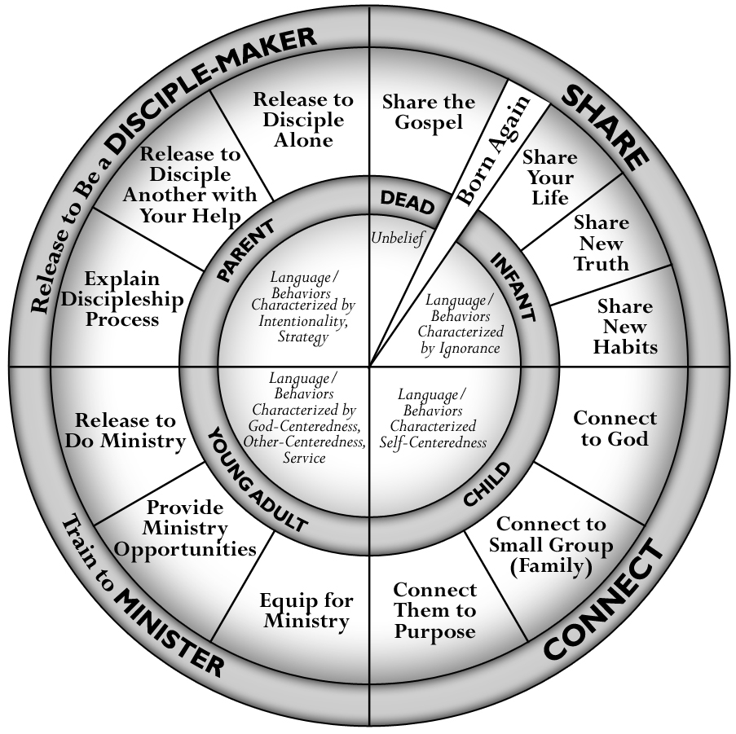
The Discipleship Wheel

Taken from Real Life Discipleship by Jim Putman

Appendix 2

Sharing Your Personal Testimony
Paul’s testimony in Acts 26 is a biblical model you can follow in writing your own personal testimony.
BEFORE- VERSES 4-11
HOW- VERSES 12-20
AFTER- VERSES 21-23

What Was Your Life Like Before You Encountered Jesus?

- Think about each phase of your life. What was your faith like during childhood, during your adolescent years, and now as an adult? Jot down some key points for each of these three phases.

- Would you say you had any encounters with God or answered prayers before your conversion? Describe them. How did these influence your understanding of God?
- Make a list of the longings and desires that shaped your journey to Christ. What obvious needs did Jesus address? Was it a sense of emptiness, a desire for forgiveness and acceptance, the longing to know God, the need to find significance, or something else? In what ways were you restless before your conversion? Try your best to describe this restlessness in terms others might recognize similarly in their lives.
- Who were the key people or groups who influenced you to follow Jesus? How did they help you move toward Jesus? Can you remember anything specific they said or did to overcome misconceptions, help you see your need for Jesus, or unsettle your thinking? What were the pivotal moments and conversations?
How Did You Meet Jesus?

- What were the circumstances of your life at the time when your faith became real? Try your best to describe this in terms others might recognize similarly in their lives.

- Can you identify a specific moment or period when you welcomed Jesus in? Where did that happen? Describe what you felt and experienced. If it happened over a longer period of time, maybe pick one or two key turning points and focus on them. If your conversion occurred early in your childhood, describe a time when you think your faith became your own, made sense, or came alive.

- If you were responding to a sermon or a Bible study, what was it about? What were the circumstances of your life that helped that message make sense?

- How did your encounter with Jesus address the longings, desires, and/or restlessness you experienced prior to conversion? How would you describe the central issue or question of your journey? How did God answer this?

- What was the role of Christian community in your surrendering to Jesus? How did the people you mentioned above play a part? How did they influence you? How did they help you understand your need for God?

What Difference Has Following Jesus Made?

- If you had to tell someone why you are a Christian, what would you say?

- How does knowing Jesus now compare to your previous (childhood, adolescent) faith?

- How did/does knowing Jesus address the longings, desires, and restlessness that you identified previously in your life? Is it just beginning to deal with these matters, or have they been completely transformed?

- How have you been changed by God? These could be subtle or obvious changes.

Take some time to write out your testimony. Write no more than 100 words on each phase of your story (before, during, and after), so your total length is 300 words. This should be about three minutes long when shared out loud.

Taken from Intervarsity: 30 Minutes to a Shareable Testimony

Appendix 3
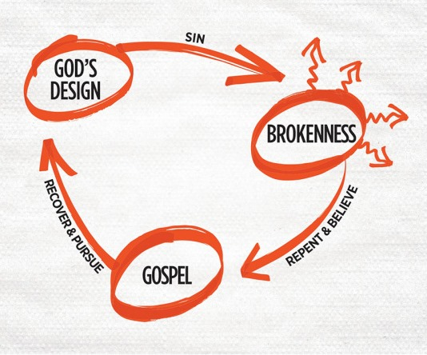

God’s Design - We see beauty, purpose and evidence of design around us. The Bible tells us that God originally planned a world that worked perfectly- where everything and everyone fit together in harmony. God made each of us with a purpose- to worship Him and walk with Him. (Genesis 1:31, Psalm 19:1)

Sin - Life doesn’t work when we ignore God and His original design for our lives. We selfishly insist on doing things our own way. The Bible calls this sin. We all sin and distort the original design. The consequence of our sin is separation from God- in this life and for all eternity. (Romans 3:23, Romans 6:23)

Brokenness - Sin leads to a place of brokenness. We see all this around us and in our lives as well. When we realize LIFE is not working, we begin to look for a way out. We tend to go in many different directions trying different things to figure it out on our own. (Romans 1:25, Proverbs 14:12)

Gospel - At this point we need a remedy- some good news. Because of His love, God did not leave us in our brokenness. Jesus, God in human flesh, came to us and lived perfectly according to God’s design. Jesus came to rescue us- to do for us what we could not do for ourselves. He took our sin and shame to the cross, paying the penalty of our sin by His death. Jesus was then raised from the dead- to provide the only way for us to be rescued and restored to a relationship with God.
(John 3:16, Colossians 2:14)

Repent and Believe - Simply hearing this Good News is not enough. We must admit our sinful brokenness and stop trusting ourselves. We don’t have the power to escape this brokenness on our own. We need to be rescued. We must ask God to forgive us- turning from sin to trust only in Jesus. This is what it means to repent and believe. Believing, we receive new life through Jesus and God turns our lives in a new direction.
(Mark 1:15, Ephesians 2:8-9, Romans 10:9)

Recover and Pursue - When God restores our relationship to Him, we begin to discover meaning and purpose in a broken world. Now we can pursue God’s design in all of our lives. Even when we fail, we understand God’s pathway to be restored- this same Good News of Jesus. God’s Spirit empowers to pursue His Design and assures us of His presence in this life and for all eternity. (Philippians 2:13, Ephesians 2:10)

Taken from 3 Circles: Life Conversation Guide by Dustin Willis and Aaron Coe
Appendix 4
My Personal Discipleship Life Path Plan
As we follow Jesus as His disciples, He continues changing our minds, our wills, our desires, and ultimately our very reason for living. Jesus wants every disciple to come to the point in their life where they realize that they exist to make more disciples. We are not called to be spectators, but players in the Great Commission. The question we must wrestle with is simple: “What is my plan for making disciples? How am I going to reproduce the life of Jesus in others?”
At Zion, we want to encourage disciples of Jesus to have a plan for growing other disciples. We pray that everyone who calls Zion home would have a growing passion to “help people far from God discover LIFE in Jesus.” We want to help you develop an intentional plan to make “personal disciple-making” a reality in your life. If we are not growing as disciples we will never grow disciples.
With that in mind, we want you to wrestle with six areas of your own discipleship. These are not exhaustive, but they are essential. They will help us flesh out the areas of our life that we need to examine and work on if we want to be growing disciples who grow disciples. As you wrestle with each question, don’t think that you have to come up with something new or creative to do in response. With many of the questions there are simple, straightforward answers that follow a pattern disciples have practiced since the book of Acts. Hopefully, many of these patterns are already in place in your life.

How will I fill my mind with Truth?
What is my plan to read God’s Word? You might start with a plan to read a chapter a day, or you can use some type of intentional plan. Youversion.com is a great resource to find a plan that will work for you.

How will I memorize God’s Word? As you read, look for verses that seem particularly important or meaningful to you. Then commit them to memory. Start with one verse a week.

How will I learn God’s word from others? Reading and understanding the Bible has to be personal, but it isn’t always private. It’s a community project. We need to listen to God’s Word being taught by faithful brothers and sisters. Identify simple ways you will learn from others.

How will I spend time with God in prayer?

When and where do I spend time with God? Having a time and place that becomes your “spot” helps to cultivate a rhythm in your life. Setting aside a time and place to pray will change your life as a disciple.

What is my plan for who/what I pray for? Without a prayer plan, prayer time can become routine and repetitive. We tend to pray for the same few things if we don’t write down our requests. Keep a journal. Write down specific things you want to pray for every day of the week.

What is my plan for listening in prayer? Prayer is a two-way conversation. How will you take time to listen to what God wants to say to you?

What is my plan for fasting? This spiritual discipline is not commanded in the Bible, but Jesus modeled it, and it was practiced by God’s people throughout the Scriptures. Try fasting one meal a week, and then grow from there.

How will I experience genuine community?

What is my commitment to my Life Group? In the middle of our busy lives, Life Group can become just another item on our list of things to do. And, if we are honest, it is one of the first things we eliminate from our schedules. How will you prevent that from happening?

What will I do to model community with my Life Group? Think about Jesus. What did He model for His disciples? How can you do the same?

What gifts (time, talents, and resources) can you give to your Life Group? When we think of using our gifts, we usually think of things inside the church. How can your Life Group benefit from your gifts throughout the week?

How will I serve my church family?

Where do I serve? We are a family. Family carries responsibility. Identify which Ministry Team you help carry responsibility with.

When do I serve? Weekly? Twice a month? Monthly? Our service to our church family should be consistent, not sporadic.

Who do I serve? Every Ministry Team serves a group of people. Do you see the people you are serving or just the task you are carrying out? Take time to write out who benefits from your service.

How will I help spread the gospel in my neighborhood, community and world?

In my neighborhood? Do you know your neighbors by name? Consider how you can intentionally spend more time with them.

In my community? Look around your community. Where do seeds of the gospel need to be planted? Plant yourself there in tangible ways you believe can make a difference.

In the world? Ever go on a short term missions trip? Why not? Consider praying regularly for another nation; then discover ways to give yourself to that nation for the sake of the gospel.

Who am I discipling to follow Jesus?

How will I share my life with them? Write down the names of 3, 5, or even 10 people God has placed in your sphere of influence. How will you incarnate the gospel with each of them?

How will I teach them to obey? This is for those whom you are more “formally” discipling. Focus on transformation, not information. Consider using this handout to help them think about their own journey; then help them live it out.

How will I model obedience? People need to see you living what you believe. This is hard because sometimes it feels like boasting. God knows your heart. Part of the discipling journey includes talking about your life as disciple. What areas can you share with others?

